


REPUBLIC OF NAMIBIA
United Nations Development Programme
Country: Namibia
GLOBAL ENVIRONMENT FACILITY
PROJECT DOCUMENT

Project Title: | Concentrating Solar Power Technology Transfer for Electricity Generation in Namibia (CSP TT) NAM.
UNDAF Outcome(s): | UNDAF 2006-2010 Outcome # 2: By 2010, livelihoods and food security among most vulnerable groups are improved
UNDP Strategic Plan Environment and Sustainable Development Primary Outcome: | CPD 2006-2010: By 2010 improved environmental living conditions and sustainable use of energy in Namibia, and establishment of sustainable living conditions in the poorest provinces.
UNDP Strategic Plan Secondary Outcome: | Strengthened capacity of local institutions to manage the environment and  Expand environment and energy services, especially to the poor.
Expected CP Outcome(s): | Outcome 1: Local entrepreneurs are engaged in supply chain for CSP plants being constructed in Namibia; Outcome 2: Increased investments in CSP technology; Outcome 3: Increased installed capacity for CSP plants in Namibia.
Expected CPAP Output (s): | National capacities of key institutions to implement global environmental commitments at national and regional levels through integration of environmental concerns in national policies and programmes improved.
Executing Entity/Implementing Partner: | Renewable Energy and Energy Efficiency Institute (REEEI), Ministry of Mines and Energy (MME).
Implementing Entity/Responsible Partners: | United Nations Development Programme

Brief Description
The proposed project aims to increase the share of renewable energies in the Namibian energy mix by developing the necessary technological framework and conditions for the successful transfer and deployment of CSP technology for on-grid power generation, thereby reducing greenhouse gas emissions. Firstly, this would be achieved through the establishment of the CSP technology partnership agreements between foreign providers and Namibian stakeholders in the private sector, government and academia. In turn, this would lead to an outcome of an increased number of local entrepreneurs in the local CSP supply chain. Secondly, the development of market policy framework for CSP technology would lead to the approval of policies supportive of its application, a thriving CSP market in Namibia, and increased investments in CSP technology in Namibia. Finally, the development of necessary documents, a business model, financing framework and contracting would lead to the provision of loans from financing institutions, the construction of Namibia’s the first 50 MW CSP plant, an increase in the installed capacity of CSP plants in Namibia, and a subsequent increase in investor confidence in the development of CSP installations in the country. Overall, these goals are set against a background of rising electricity consumption and prices in Namibia and power deficit in the Southern African Power Pool member states and South Africa, the country’s main supplier.
Programme Period: 2013-2015
Atlas Award ID: tbd
Project ID: 4163
PIMS # 4334
Start date: January 2013
End Date January 2016
Management Arrangements NIM
PAC Meeting Date February 2011
Total resources required $ 2,138,000
Total allocated resources:
- GEF $ 1,718,000
- Ministry of Mines and Energy $ 340,000
- Polytechnic of Namibia (REEEI) $ 80,000
- Development of Southern Africa $200,080,000*
- Clinton Climate Initiative $ 100,000*

* These are estimated amounts based on the Letters of Interest submitted by these organizations that provide details of proposed assistance

Agreed by (Government):

Date/Month/Year

Agreed by (Executing Entity/Implementing Partner):

Date/Month/Year

Agreed by (UNDP):

Date/Month/Year

Table of Contents

List of Acronyms and Abbreviations 2

SITUATION ANALYSIS 2
Context and Global Significance 2
Defining the Challenge 2
Barrier Analysis 2
Stakeholder Analysis 2
Baseline Analysis 2

STRATEGY 2
Project Rationale and Policy Conformity 2
Country Ownership 2
Country Drivenness 2
Design Principles and Strategic Considerations 2
Project Objectives, Outcomes and Outputs/Activities 2
Key Indicators, Risks and Assumptions 2
Financial Modality 2
Cost Effectiveness 2
Sustainability 2
Replicability 2

PROJECT RESULTS FRAMEWORK 2
Total Budget and Work Plan 2

MANAGEMENT ARRANGEMENTS 2

MONITORING FRAMEWORK AND EVALUATION 2

LEGAL CONTEXT 2

ANNEX 1: RISK ANALYSIS 2

ANNEX 2: TERMS OF REFERENCE 2

ANNEX 3: ENVIRONMENTAL AND SOCIAL ISSUES 2

ANNEX 4: FINANCIAL AND IMPLEMENTATION ISSUES 2

ANNEX 5: DETAILED CO2 CALCULATONS AND ASSUMPTIONS 2

SIGNATURE PAGE Error! Bookmark not defined.

List of Acronyms and Abbreviations
APR/PIR | Annual Project Review/Project Implementation Reports APR/PIR
DRFN | Desert Research Foundation of Namibia
ECB | Electricity Control Board
ESI | Electricity Supply Industry
GEF | Global Environment Facility
GHG | Greenhouse Gas
GRN | Government of the Republic of Namibia
GW | Gigawatt
GWh | Gigawatt-hour
HRDC | Habitat Research and Development Centre
INC | Initial National Communication
IPCC | Intergovernmental Panel for Climate Change
kW | Kilowatt
M&E | Monitoring and Evaluation
MET | Ministry of Environment and Tourism
MME | Ministry of Mines and Energy
MRLGHRD | Ministry of Regional and Local Government, Housing and Rural Development
MW | Megawatt
MWh | Megawatt-hour
MWT | Ministry of Works and Transport
NCCC | Namibia Climate Change Committee
NEEP | Namibia Energy Efficiency Programme
NGO | Non-Governmental Organization
NIA | Namibia Institute of Architects
NMA | Namibian Manufacturers Association
POPP | Programme And Operations Policies And Procedures
ProDoc | UNDP/GEF Project document
RE | Renewable Energy
RED | Regional Electricity Distributor
REEEI | Renewable Energy and Energy Efficiency Institute
SAPP | Southern African Power Pool
UNDP | United Nations Development Programme
UNFCCC | United Nations Framework Convention on Climate Change

Currency Equivalents
Currency Unit | = | Namibia Dollar, NAD
1 USD | = | 7.928 NAD

SITUATION ANALYSIS

Context and Global Significance

- The Republic of Namibia is a vast country, the 31st largest in the world, and covers an area of about 824,268 square kilometres. The country is located along the South Atlantic coast of Africa and shares borders with South Africa, Angola, Zambia, Botswana and Zimbabwe (Fig. 1). Namibia is sparsely populated with only one third of its 2.1 million inhabitants living in urban centres. Namibia is currently experiencing a population growth rate projected at 3% per annum by the Population Reference Bureau. It is a lower middle-income country with a GDP per capita close to USD 1,800.

- Namibia’s total electricity consumption was 3,910 GWh in 2010 of which about 39% was imported from South Africa, whose 90% of grid supplied power is coal-based generation and 16% from Hwange coal–fired powered station in Zimbabwe. NamPower has a 150MW firm supply contract with Zimbabwe. Of Namibia’s 393 MW of in-country generating capacity, almost 36.6% is fossil fuel based. Average annual growth in electricity demand is estimated at 3% over the next 30 years. At the same time, the Namibian Government is pursuing a policy of energy security by promoting a diversified energy mix which will ensure that the national economy does not become overly dependent on one source of energy. With the projected growth in demand and given the Government’s policy of seeking to achieve an energy mix that ensures energy security, it is clear that the country’s electricity generating capacity needs to be enhanced with the focus on developing its own energy sources, including renewable energy, and solar energy in particular. Namibia has pristine conditions for solar energy based generation with high Direct Normal Irradiance (DNI) of up to 3,000kWh/m²/annum and generally flat terrain.

Figure 1: Map of Namibia

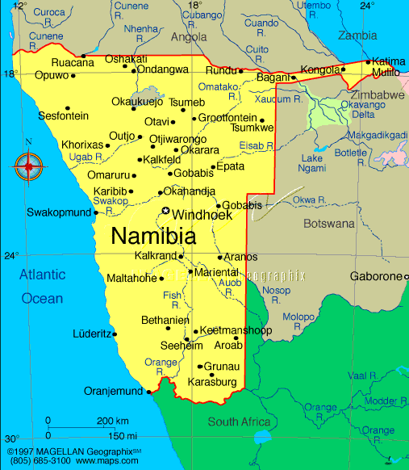

- According to the Electricity Control Board (ECB), total units generated into the Namibian electricity system increased from 3,554 million kWh in 2006 to 3,767 million kWh in 2010, an increase of 1.5% per annum. Moreover, energy consumption in the entire country has increased by an average of 4% per year between 1997 and 2003, 20% per year between 2003 and 2004, and 13% between 2004 and 2005.

- More recently, a GRN study indicates that Namibia faces a capacity deficit in its generation capacity from 2015 due to current growth forecasts of its electricity demands. Much of this deficit is due to strong growth forecasts in the SADC region where energy exports from South Africa may be reduced during mid-peak to peak periods. This represents over 1,932 TWh between 2013 and 2016, mainly during the dry season. Other countries within the SADC such as Tanzania are already making short term investments in power generation to fill in the generation gap with rental diesel plants. The estimated cost for rental diesel power plants to overcome Namibia’s short-term energy gap (2012-2015) is around USD 1.0 million. The electricity from these plants, however, are costly both financially (~USD 0.50/kWh) and environmentally (emissions of 1.02 tonnes CO₂/MWh); the opportunity costs of the business-as-usual scenario are far greater from lost production and other economic activities. The GRN are currently determining the best strategies to overcome the looming energy shortages forecast for 2015.

- In terms of the impacts of climate change, the Initial National Communication (INC, 2002) classified Namibia as highly vulnerable to the predicted effects of climate change. Climate change models used during the process predicted that it will become increasingly hotter and drier in Namibia with shorter and less reliable rainy seasons. Droughts will become more frequent. Climate sensitive sectors include agriculture, water, energy, biodiversity, health, tourism and coastal zones. The Second National Communication (SNC, 2010) underscores the most significant barrier to widespread implementation of proven Renewable Energy Technologies (RETs) is the lack of reliable and commercially available financing for end-users, developers, contractors, manufacturers and vendors. Recommendations are made for measures which would strengthen the local capital market for the financing of such projects, and for building capacity around CDM projects.

- Namibia was estimated to be a net sink for carbon dioxide in 1994 due to the large uptake of carbon dioxide by trees into their woody tissues. The woody biomass in Namibia’s vast areas of rangeland is believed to be increasing. Namibia has a relatively small economy with little impact on global emissions (i.e. it contributed less than 0.05% to global CO₂ equivalent emissions in 1994, even when the carbon sink is excluded). The amount of carbon estimated to be taken up by the natural vegetation in Namibia in 1994 constitutes about 0.1% of the total net uptake by land ecosystems throughout the world.

- Namibia has one of the best solar regimes in the world with an average direct insulation of 2,200 kWh /m²/year and minimal cloud cover as shown on Figures 2 and 3. In recognition of this unique endowment, the Government has actively promoted the use of solar energy and uptake of solar energy has increased significantly as a result of Government efforts. This has been almost exclusively for off-grid applications. Off-grid solar electrification is set to continue for the next 20 years, under the Off-Grid Energization Master Plan. However, to more fully exploit its solar energy potential, Namibia is well placed for the development of grid-fed solar thermal power-generated electricity, particularly considering the availability of vast areas of land with ideal conditions for large scale solar power electricity generation. Solar thermal generated power fed into the grid will help Namibia reduce the carbon intensity of its current electricity supply and contribute to security of supply through lessened dependence on electricity imports by promoting an optimal energy mix. Current estimates of Namibia’s excellent solar regime indicate that Namibia’s DNI ranking is the best globally and that CSP in Namibia can provide more than 250,000 MW of power generation capacity.

Figure 2: Sunshine hours per year in Namibia
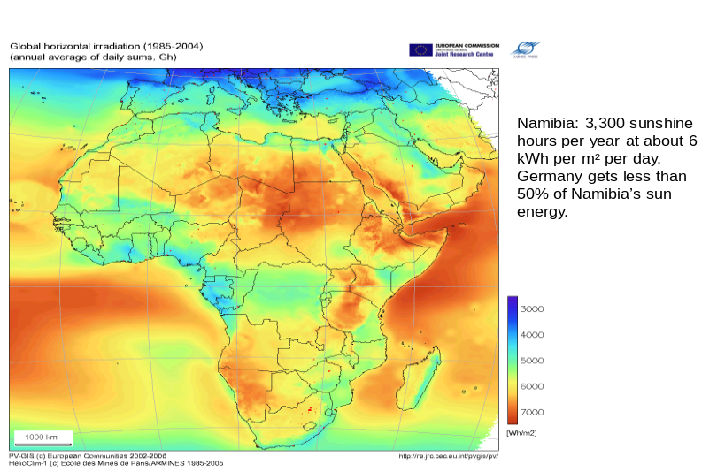

Figure 3: Sunshine in Namibia in kWh per m² per day
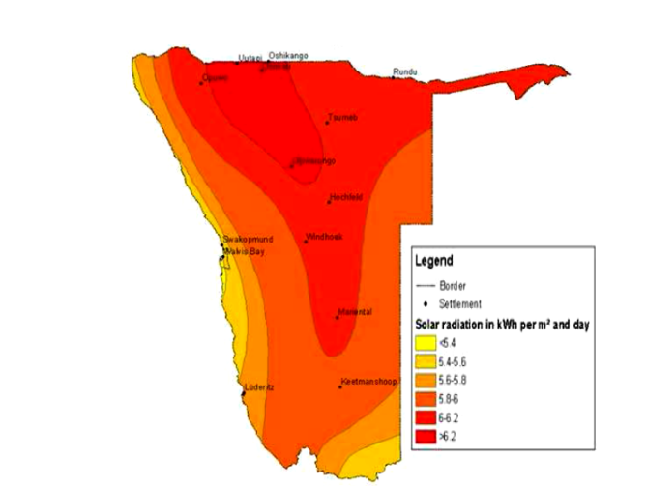

- CSP is a commercially available solar energy technology that uses direct sunlight (technically known as the DNI) and mirrors to create high temperature steam to drive conventional steam turbines with or without storage. A typical CSP power plant as shown on Figure 4 is comprised of the following components; solar field (e.g. the Nevada Solar One as shown on Figure 5), power block, thermal storage (optional), cooling tower and all other components found in any thermal power plant except the heat source. While a number of CSP candidate technologies for utility-scale applications were recently studied, only parabolic troughs and central receiving system (tower technology) are being considered for the initial CSP investments. In the last decade, several companies have emerged as leaders in the various CSP technologies. With respect to the trough systems, key players include Abengoa Solar (Spain), Acciona (Spain), FPL Energy (USA), Solar Millennium (Germany), Solel (Israel), and SkyFuel (USA). For tower systems, the market players include Spanish company Abengoa Solar, and the US companies, Bright Source Energy, eSolar, and Solar Reserve.

Figure 4: Typical CSP plant schematic diagram
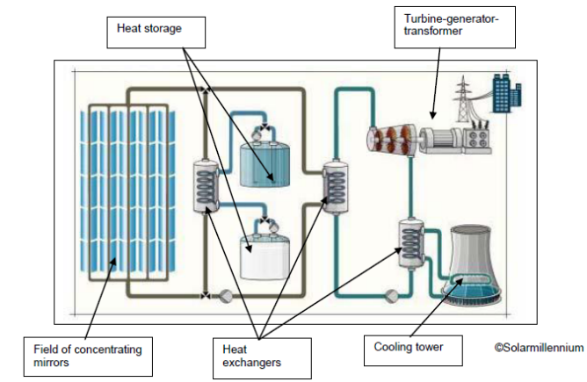

Figure 5: Nevada Solar One, USA

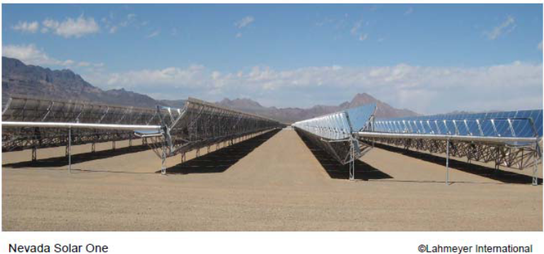

- There are several projects at various stages of development around the world to develop CSP power such as Andasol I-III in Spain (supported by the Royal Decree 436/2004), Aachen University (Germany), Kuraymat (Egypt) and DESERTEC (North Africa).

- CSP for electricity generation has proven its feasibility as an energy source for the “post-fossil fuel” era. At present, a total of 354 MW_{e} of installed capacity is operating commercially in the Californian desert. At the same time, national and international investment in research, development, demonstration and dissemination continues to yield important technical improvements. CSP is one of the most innovative forms of solar technology that could meet a large portion of the world’s demand for electricity. Globally, the number of CSP plants installed is more than 2,183 MW and studies show the technical market potential CSP to be more than 600,000 MW over the next 20 years. At this scale. CSP could therefore make a major contribution to the reduction of greenhouse gas (GHG) emissions. However, due to the current costs of USD 0.12 to 0.18 per kWh of electricity produced by CSP plants compared to the production from conventional sources, applications of CSP are currently limited to areas that provide the best solar radiation and investment framework. Moreover, sustainable energy production with CSP technology will only be viable if energy production and capital costs are reduced.

- Increased use of the technology through demonstrations and dissemination, coupled with research and technological development as well as appropriate financial incentives, is expected to play a key role in achieving the successful development of the industry. In terms of its commercial viability as a power generation option, CSP falls between wind power and photovoltaics (PV) in terms of $/kWh and represents a technology that is ready for scale-up in developing countries and has yet to experience cost reductions resulting from significant scale-up of manufacturing volume.

- The most significant added value of CSP is its potential for energy storage coupled with hybridization potential with biomass, natural gas and coal. Two technologies, parabolic troughs and power towers, can offer storage while a third technology, linear Fresnel reflectors, can also play a role on all hybrid projects.

- With this in mind, several Namibian stakeholders from both the private and public sector (supported by various partners) are currently involved in initial discussions and actions focused on promoting the development of the CSP technology in Namibia including:

- The Energy and Environment Partnership with Southern and East Africa (EEP S&EA), a sustainable energy promotion programme funded by the Governments of Finland, Austria and the United Kingdom. EEP S&EA provided funds for the July 2012 CSP pre-feasibility study by REEEI that has provided most of the information used in the development of the ProDoc;
- Clinton Climate Initiative;
- Development Bank of Southern Africa;
- NamPower (state owned power utility);
- the Namibian Electricity Control Board;
- CENORED Pty Ltd and other Namibian electricity distribution companies;
- The Renewables Academy AG (RENAC), through the Transfer Renewable Energy & Efficiency (TREE) project with financial support from the Germany Federal Ministry for the Environment, Nature Conservation and Nuclear Safety, conducted CSP seminars in five (5) different countries including Namibia in March and April 2009. Namibia’s CSP Seminar, held between 23 -25 March 2009 and coordinated by REEEI, drew participants from both industry and academia;
- Rössing Uranium Limited (a Namibian Rio Tinto mining subsidiary) is exploring the use of CSP technology to generate process heat based on the information received during the 2009 seminars. Rössing has a research cooperation agreement with the Polytechnic of Namibia (PoN) and have indicated their desire to collaborate on this particular project; and
- REEEI through its parent organisation, PoN, has cooperation agreements with FH Aachen which hosts the Solar Institute Jülich (SIJ) and RENAC

- The presentation of the CSP Pre-feasibility study on 25 July 2012 in Windhoek attracted participants from South Africa, Germany Israel, Portugal and the United States of America. In addition, renewable energy market-leading countries such as Spain, are exploring the possibility of tapping into the Namibian and Southern African markets based on their global expertise.

Policy Context

- White Paper on Energy Policy of Namibia published by the Ministry of Mines and Energy in 1998 embodied a new, comprehensive energy policy aimed at achieving security of supply, social upliftment, effective governance, investment and growth, economic competitiveness, economic efficiency and sustainability. Policies sought to affect energy demand (mainly households), supply and a number of cross-cutting issues, including energy efficiency and regional energy trade and cooperation. The White Paper on Energy Policy, under the energy supply section, projects the exploitation and development of the electricity, upstream oil and gas, downstream gas, downstream liquid fuels, and renewable energy (RE).

- RE within the policy is clear with regards to the following interventions:

- Institutional and development challenges;
- Institutional and planning framework;
- Human resources development and public awareness;
- Adequate financing schemes for RE applications;
- Inter-ministerial co-operation structure development;
- Energy access improvement in rural areas for households, water supply, and business and public services;
- Rational use of energy in buildings and for water heating.

This energy policy set ambitious targets of meeting at least 100 percent of peak demand and at least 75 percent of total electricity requirements from internal sources by 2012, as well as matching Namibia’s energy requirements in a cost-effective manner and sourcing 10 percent of the supply from internal RE sources. NamPower has selected various supply and demand options to meet the Namibia’s energy requirements driven by the Energy White Paper.

- The Renewable Energy Policy Paper for NamPower was developed and approved by the Electricity Control Board (ECB) and the Ministry of Mines and Energy. According to this policy, NamPower is expected to intervene in broader areas of wind energy, biomass energy, hybrid mini-grid systems for off-grid areas, solar energy, and skills development in the RE fields. The utility was expecting to reach its first target for RE of about 40MW by the year 2011. As solar energy is a plentiful resource in Namibia, the Government’s Ministry of Mines and Minerals (MME) made the necessary arrangements for the installation of solar water heaters in all government and parastatal buildings.

- Regional energy trade and cooperation is an important cross-cutting theme of the Energy White Paper. Namibia’s neighbour, South Africa, as part of the Southern African Power Pool (SAPP) has also implemented a number of short-term measures to accelerate the region’s power shortage recovery, namely guidelines for effective inter-utility transmission networks connectivity. On the supply side, the National Energy Regulator of South Africa (NERSA) approved the Renewable Energy Feed-In Tariff (REFIT) Guidelines in 2009. REFIT provided Power Purchase Agreements for R3.94 (USD 0.50) per kWh to CSP developments in South Africa, a higher rate than for other renewable energy technologies for electricity generation. The REFIT, however, was subsequently abandoned in favour of a bidding process due legal challenges of implementing the REFIT.

- VISION 2030 was adopted in 2003 with the goal of industrialising the Namibian economy such that by 2030, 80% of the GDP is derived from the manufacturing and service sectors. Sections 2 and 3 of Namibia`s Development Plan (NDP) contain the directives of the White Paper on Energy Policy of 1998 that seeks to meet development challenges through improved access to RE sources, particularly in rural electrification, rural water supply and solar housing and water heating. With regard to renewable energy, NDP 3 sets the target of 10% total energy consumed are derived from renewable energy by 2012. NDP 4 has just been launched with sectoral discussions to commence soon.

- Off-Grid Energisation Master Plan for Namibia (OGEMP) is another Vision 2030 project that was initiated by the UNDP/GEF/MME Barrier Removal to Namibian Renewable Energy Programme (NAMREP). The underlying objective of the OGEMP is to provide access to appropriate energy technologies to everyone living or working in off-grid, pre-grid and ‘‘grey’’ areas.

- Other relevant plans and strategies include the 2009 Climate Change Strategy and Action Plan, the 2010 National Policy on Climate Change in 2010 issued by the GRN, and the Electricity Control Board (ECB) who the initiated National Integrated Resource Planning Study of 2010.

Institutional Context

- The development of grid-connected renewable energy will contribute to the country’s energy security; enable the country to meet the energy requirements of achieving Vision 2030 as well as increase opportunity for new manufacturing industries. However, the White Paper recognises the need for institutional capacities and planning frameworks to be conducive and facilitate the development of viable renewable energy projects. Within this context, the following institutions will play critical roles in the implementation of grid connected renewable energy projects including CSP.

Government Ministries:

- The Ministry of Mines and Energy (MME): The MME is responsible for ensuring the adequate and affordable energy supply in a sustainable manner taking advantage of Namibia’s natural resources in support of the nation's socio-economic development by formulating and implementing enabling policy frameworks. One of the MME objectives is to make sure that increases of energy supply and utilization are sustainable, competitive and economically efficient. At the same time MME aims to increase the proportion of renewable energy in Namibia’s final energy consumption is increased. To this end, the Ministry of Mines and Energy has published the Energy White Paper in 1998 and the Demand Side Management report under the Electricity Control Board.

- The Ministry of Environment and Tourism (MET): The MET has initiated capacity building for a policymaker’s project that seeks to strengthen the national capacity of Namibia to develop policy options for addressing climate change across different sectors and economic activities. This could serve as inputs to negotiating positions under the United Nations Framework Convention on Climate Change (UNFCCC). The national capacity building projects entail:

- Adaptation to Climate Change;
- Climate Change Mitigation;
- Mitigation Technology Challenges;
- Investment and Financial Flows;
- National Policies and their linkages to negotiations over a future of Climate Change Agreement;
- Key issues on Land Use, Land Use Change and Forestry (LULUCF).

- The Ministry of Trade and Industry (MTI) - To ensure a continually responsive, investor-friendly climate, the ministry introduced a number of special incentives for manufacturers and exporters including:

- Widening the incentive range from the provision of significant tax deductions to concessional loans and indirect subsidies on marketing and training costs;
- provision of tax abatement of 50% for manufacturing activity;
- writing off provisions of up to 20% or less annually on buildings erected for manufacturing purposes;
- Deductions for marketing, training, wage, and feasibility study costs; and
- Such incentives could increase the viability of renewable energy investors in Namibia.

Regulatory / Utility Agencies:

- The Electricity Control Board (ECB): The ECB is the regulator of the electricity supply industry. The core mandate of the ECB is to exercise control over the electricity supply industry with the main responsibility of regulating electricity generation, transmission, distribution, supply, import and export in Namibia through setting tariffs and issuance of licenses.

- One of ECB’s objectives is to ensure a competitive environment by facilitating the increase in the number of participants in the electricity supply industry and encourage greater investment in generation. In this regard, the ECB has completed a number of regulations aimed at encouraging entry into the market of Independent Power Producers (IPPs), notably, the IPP and Investment Market Framework and Grid Code. The ECB started also the process to develop a National Integrated Resource Plan (NIRP) to ensure that new power stations are introduced according to a schedule that is consistent with national energy planning, as well as to ensure the optimal utilisation of resources and the diversification of the generation mix in Namibia to mitigate the risk of over-reliance on imports.

- Since 2000, the ECB has introduced a number of measures aimed at improving the competitive environment by moving towards cost reflective tariffs for grid-fed energy generation and increasing the number of players in the industry, notably the formation of Regional Electricity Distribution Companies (REDs) operating at the sub-national level (ERONGORED, CENORED and NORED). In Figure 6, the prevailing market structure in Namibia which is a ‘‘Single Buyer Model’’ is illustrated. Presently, the ECB contemplates the creation of a modified single buyer market structure. The model will be similar to a wholesale market where there are multiple buyers and sellers of electricity. REDs and other distributors will be able to buy power directly from the IPPs.

Figure 6: Namibia Single Buyer Model

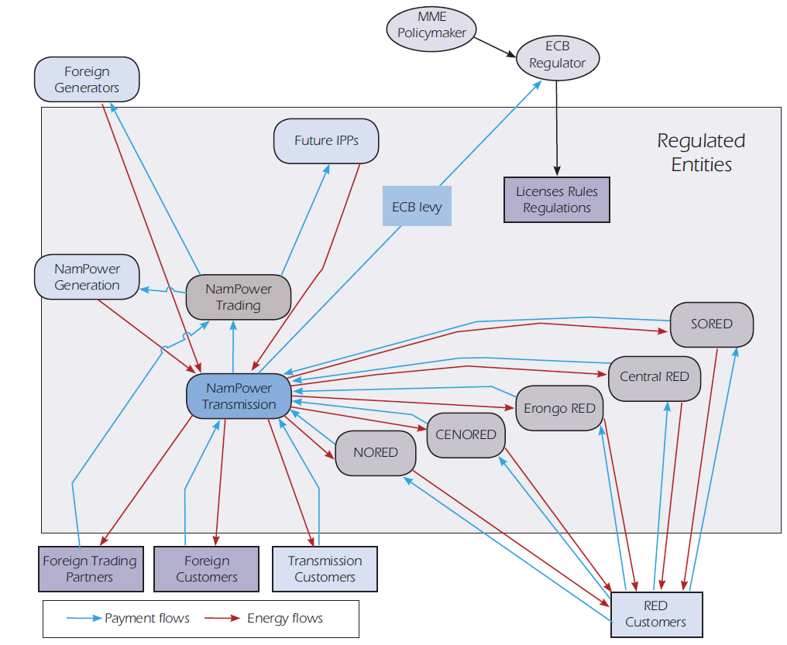

- NamPower is a semi-autonomous government agency that is currently the country’s only supplier of electricity through its generation, transmission, trading and single-buyer activities. The electricity supply industry is regulated by the Electricity Control Board (ECB) which sets tariffs and issues licences to operators in the industry. NamPower’s role in a modified single buyer model remains critically important, especially to maintain system balance in real time, and NamPower will also remain the supplier of last resort.

- The Regional Electricity Distributors (REDs): A “RED” is a regional electricity distributing company tasked with supplying electricity to the residents in a specific region. In 1998, the MME recommended that Namibia be divided into five areas and that a single electricity distributor be established for each area solely responsible for electricity distribution in that area. In order to consolidate all distributions in an area, all electricity distributors in such area voluntarily join their electricity businesses in a single private entity, a RED. The Namibian Cabinet has approved the establishment of REDs in Namibia since 2000. REDs are established through private companies with all initial shareholding by Government-owned or public entities. They are concerned with electricity supply and creating conducive conditions for the achievement of Vision 2030.

Financial Institutions

- Development Bank of Namibia (DBN) – The availability of suitably structured financing is critical for the commercialisation of CSP in Namibia. The DBN is the premier provider of development financing in Namibia. DBN fosters, empowers and finances bold new ventures. Whether large or small, a start-up or expansion, private or public sector, the Development Bank of Namibia generates success, innovation, growth and prosperity. The Bank provides finance for private sector start-ups and expansions, equity deals, bridging finance, enterprise development finance, trade finance, small and medium enterprises, public private partnerships, public sector infrastructure, local authorities, and bulk finance to responsible micro-finance providers. The DBN only finances Namibian participation in projects.

Academia and Research Institutions:

- The Renewable Energy & Energy Efficiency Institute (REEEI) of Namibia: The REEEI is a national energy institute of the Polytechnic of Namibia dedicated to serve as a national information resource base for RE, sustainable energy use and management, and conducting policy research. The institute has provided energy management training and is enhancing its capacity to be able to work more effectively with the private sector in promoting RE & EE and supporting activities on the ground. REEEI was established and is funded by MME and the Polytechnic of Namibia to promote RE & EE through research & development. The Institute was commissioned to undertake the CSP Pre-feasibility Study in January 2012. REEEI is the implementing partner of CSP TT NAM.

- Desert Research Foundation of Namibia (DRFN): The DRFN is a Namibian non-governmental sustainability organization aiming to enhance decision making for sustainable development through research, training and consultancy in the country’s land, water and energy sectors. DRFN provides objective, relevant and professional services supporting decision makers from communities to traditional and local authorities, from the highest decision making bodies and individuals in government and private sector. This is achieved by developing, disseminating and implementing scientific, fact-based and analytical options that form the backbone of policy development, planning and implementation, thereby contributing to Namibia’s sustainable development. On the energy front, DRFN have a dedicated Energy Desk who believes that the greater use of RE sources, diversification into alternative energy sources, and greater efficiency in the use of power can all make Namibia’s energy consumption more sustainable. The Energy Desk is involved in realizing some of these great opportunities.

- Namibia Manufacturers Association is an association of Namibian manufacturers engaged in lobbying and advocacy for manufacturing in Namibia. The association aims to achieve the situation where Namibia will be the African destination of choice for investment in manufacturing. By 2020, it will be the highest ranking Sub-Saharan African country in the WEF global competitiveness rankings. Manufacturing will be a major contributor to Namibian GDP with an average growth rate of more than 7% per annum. The Association has drafted a manufacturing strategy which has been accepted by the Ministry of Trade and Industry.

- Engineering Professions Association is a non-profit, voluntary membership association of engineering and related professionals in Namibia. The Association strives to uphold excellence in the field of engineering by promoting the profession through continuing education and common interests of its members. Its membership comprises from all engineering disciplines that will play a pivotal role in the development of CSP in Namibia.

Defining the Challenge

- The GRN recognizes its urgent need to develop additional generation capacity to meet the expected electricity shortages forecast for 2015 and beyond. Building on the interest expressed among local actors, Namibian stakeholders are now eager to take necessary steps to contribute to the development and implementation of locally-specific CSP technology policies and platforms by engaging in technology transfer and pre-commercial demonstration schemes. Moreover, the GRN views CSP as a key technology to bridge the forecasted 2015 energy deficit. The current challenge for the GRN, however, is to be able to implement specific power projects included in their 2012 short-term strategy that would include a:

- “1st step” that includes the development of 100 MW of wind, PV and backup diesel projects by mid-2014; and
- “2nd” step that would include 100 MW of CSP by mid-2015.

An indicative timeframe to develop these power generation sources is shown on Figure 7. This approach would not only guarantee the fastest development of local capacity as well as the least cost, it would also promote the development of renewable technologies in Namibia. The funding available under the GEF-4 Resource Allocation Framework will provide a key strategic entry point to achieve that goal.

- Namibia has one of the best solar regimes in the world peaking to 3000 kWh/m²/year in certain areas and minimal cloud cover and aerosols, and is strongly intent on developing this important resource through CSP projects as a part of its response to the challenge of sustaining and increasing its economic growth. As such, the CSP industry will play an important role in Namibia in the years to come. As the Namibian energy sector faces considerable financing needs which cannot be mobilized entirely from public sources, overcoming funding constraints is a major challenge for Namibian policy makers. Furthermore, the way in which these constraints are overcome will, to a large extent, determine the country’s ability to equip industries and households with clean energy in the medium to long term utilizing Namibia’s excellent solar regime that has the potential for more than 250,000 MW of power generation on suitable land.

- The GRN through its policy framework, institutional and regulatory framework is in a position to aggressively promote energy access through state-owned power utility NamPower and the REDs as well as bringing on board IPPs in the country. The financial envelope for short, medium and long-term investment projects is estimated at USD 1 billion. The power utilities and IPPs are rapidly rolling out new approaches for grid-based, isolated and stand-alone electricity services. New generation capacities through a recently developed hydropower master plan identified production for all potential hydro power projects in the Lower Kunene, Kavango and Lower Orange Rivers while the CCGT Kudu gas project has been in the pipeline for the past 20 years for development.

Figure 7: Indicative Timeframe for Development of Power Generation Sources between 2012 and 2015

2012
–
2nd
Semester
2013
–
1st
Semester
2013
–
2nd
Semester
2014
–
1st
Semester
2014
–
2nd
Semester
2015
–
1st
Semester
2015
–
2nd
Semester
1st Step
Wind or PV &
Backup diesel
2nd Step
CSP with
development
financing
Negotiate PPA
under IPP regime
All renewable
promoters
required to
install and
transfer(?) to
Nampower diesel
backup engines
Delivery and
installation of
Diesel backup
engines
Installation of wind and solar PV projects
(only wind projects with measurements can
provide energy in the required time frame)
Operation startup (up to 150 MW)
Operation startup reducing diesel oil
consumption
Feasibility study
Environmental
screening
Negotiation with
Development
institutions
Selection of
Strategic partner
EPC procurement
Financial closing
Environmental
authorization
Installation of CSP project
Operation
startup

- In the event that financial needs act as a “brake” on energy related project development, economic growth will be hampered increasing poverty. Therefore, development of a robust and broad-based private sector is the only means by which sustained growth of CSPs can be achieved in Namibia; the CSP TT NAM project can catalyse the development of the CSP private sector. Financial market frictions can be the most critical mechanism for generating persistent income inequality or poverty traps. There is also a significant and robust relationship between financial depth and economic growth. Financial depth is not only associated with a higher growth rate but it also has an additional pro-poor effect, disproportionately boosting the income of the poor. A case in point is the Namibia Renewable Energy Programme (NAMREP) which was designed to address some of the barriers experienced in the dissemination of renewable energy technologies in Namibia. Indeed, the programme created demand for renewable energy technologies (RETs) and maintain a large clientele base.

- The acceleration of CSP projects and in general, renewable energy development in Namibia will need to respond to its energy policy and planning that is guided by the Energy White Paper of 1998. Energy has also been integrated as cross-cutting topic into the national vision and development plans, specifically NDP3. Vision 2030 spanning a 20-year period has consequently been formulated to that effect for the transformation of Namibia into an industrialised nation, with viable natural resources based export sector, and increased size of skills-based industrial and service sectors as well as a market oriented production. This vision necessitates a rapid industrialisation that will place significant pressure on the Namibian electricity supply industry, and challenge its growth and ability to deliver electrical energy on demand.

- The Vision will open new opportunities for independent power generation plants that the CSP TT NAM Project aims to catalyse through improving the enabling environment for CSP investments. This would include improving the assessment of the solar resource, thorough analysis of available technologies, improved governmental support on potential CSP sites and regulatory permitting requirements, and financial access. In addition, there are also capacity barriers and challenges within the mandated institutions related to policy development and implementation that must be addressed to catalyse the development of CSP projects.

Barrier Analysis

International Context

- High initial capital costs are the most important barrier for the expansion of CSP. As much as 87 percent of the cost of electricity produced by a solar thermal plant is related to the initial capital investment and installation cost, with the remaining 13 percent being the cost of operating and maintaining the plant. Estimates range the capital costs between $4,000 and $6,000 per kW for typical capacity factors in the range of 22-24 percent. Therefore, a CSP plant is still not competitive with fossil-fuel fired plants or even with wind energy plants. For example, CSP plant costing $4,000/kW operating at capacity factors of 22-24 percent can be around four times as expensive as combined cycle gas turbine plants.

- There is broad consensus within the industry circles, however, that there is high cost reduction potential for CSP due to three factors:

- First, manufacturers have to yet to benefit from economies of scale. The history of PV suggests that doubling of capacity leads to a 20 percent reduction in costs. Scale benefits include longer and more automated production runs, purchasing power on sourcing components and materials, and bigger R&D budgets. Furthermore, if the average CSP system size increases to several hundred MW, this is likely to work out cheaper per MWh because of the scale leverage on a central turbine and grid connection. There have been several estimates on the cost reduction possibilities; for example, one estimate predicts a reduction from USD 4,943/kW for a 100 MW in 2007 to USD 3,157/kW for a 200 MW plant in 2015, reflecting a decrease of 8.6 percent per year;
- Second, technical improvements can be realized in certain components and accelerated when companies R&D respond to increased global demand. For example, between 1991 and 2004 technology advances helped reduce O&M costs by 30 percent and improve annual solar-to-electric efficiency by 20 percent for parabolic trough systems. Solar thermal companies are exploring more cost effective construction of collectors, wider diameter absorber tubes to reduce pumping costs and direct steam generation in receivers. New optical configurations (mirror alignment, tracking systems, and types of transfer of fluids) could lead to higher efficiencies or load factors. Companies are also exploring different storage materials and reflective surfaces that could lead to higher efficiencies. Finally, one third of the system cost is construction and installation; hence, improvements in structural design and introduction of new materials would reduce the weight of systems (transport costs) and complexity (installation costs). Storage technology in CSP plants also needs further development as there is only one such commercial plant in operation in Spain. A large thermal storage system with a storage capacity of up to 7 hours can provide electricity during periods without sunshine and thus supply power during peak demand in the evening. The higher investment for a storage facility, such as a molten salt thermal storage tanks (with a storage capacity of approximately 1,000 MW_{th}) is compensated by the higher reliability and flexibility that will allow the plant operator to dispatch the solar energy to the grid when wholesale prices are higher;
- Third, increased demand will result in a more diverse supply chain which will reduce component costs. New entrants are entering the market for components that are currently supplied by a small number of companies. Larger companies with experience in achieving economies of scale through mass production are also entering the CSP market in anticipation of market growth. An example of this is the recent acquisition of Solel solar systems by Siemens AG.

- A gigawatt-scale regional CSP deployment program has the potential to drive cost reductions by virtue of volume production, increased plant size, and technological advance. Given the uncertainties of future business, supply industries have operated on the basis of serving one-off customers instead of setting up complete R&D, large-scale manufacturing, and operations and maintenance programs. The result is very high cost, underexploited economies of scale and limited investment in R&D leading to technology development and innovation.

- A deployment program of 10 to 12 utility-scale CSP plants in a number of countries would send a strong signal to the market that would enable industry to plan manufacturing capacity expansions, which is central to driving down the costs of solar thermal technology and production processes. The proposed GEF CSP program would thereby make a major contribution to accelerating global market momentum.

Namibian Context

- There are still a number of barriers, however, that inhibit the establishment of CSP plants in Namibia including those discussed in the following paragraphs.

- Insufficient capacity and CSP awareness of local industry: The participation of local industry in the supply of some components and services to a CSP project would potentially reduce costs. Components such as civil works, installations on site, connecting piping, electronic equipment have been estimated to constitute about 22% of the capital costs whilst services such as engineering project management services amount to about 8% of the capital costs. Namibia has had a limited industrial development and continues to import most of the manufactured products, mainly from South Africa. The largest manufacturing sector in Namibia is the food sub-sector followed by chemicals and plastics. While the manufacturing sector does have potential to participate in the CSP value chain, there is a lack of skilled technicians and labor. In addition, there are a number of engineering consulting firms that have not yet had the exposure to CSP projects, but could provide project management services and be given some exposure to CSP technology and specific CSP project management knowledge. There have been recent efforts through to bring foreign CSP players into the Namibian CSP market, a scoping and due diligence analysis of global players had been done using some of the networks created through the CSP Pre-feasibility Study and TREE project CSP Seminars in 2009. More sustained efforts to link local companies to foreign CSP equipment providers can provide local companies with invaluable opportunities to participate in the CSP value chain when the CSP projects are developed in Namibia.

- Inadequate financial and regulatory frameworks: Investors in general have tended not to invest in large-scale renewable energy technology in developing countries, including Namibia, due to the lack of support mechanisms such as appropriate financial and regulatory frameworks. The recent CSP Pre-Feasibility Study (July 2012) underscored the deficiencies of the current regulatory framework that is currently not conducive to CSP investment. For renewable energy projects in Namibia:

- Independent power producers (IPPs) must be able to have access to the electricity market and to sell electricity at a price that provides a sufficient return on the high CSP investment. This can be accomplished either through equitable regulated purchase tariffs or more generally through power purchase agreements (PPAs) to a distribution company or distant consumer (wheeling). Unfortunately, in Namibia, purchase tariffs are nonexistent, PPAs are poorly designed, and regulators do not allow the wheeling of excess power production through existing national grids;
- Transmission costs of a CSP plant can be significant since most suitable CSP sites are located far from population centres;
- Local grid codes, guidelines and standards are not well-suited for renewable energy generation which is variable and different from conventional generation sources from fossil fuels;
- The regulatory framework of the electricity sector does not address monitoring and regular reporting of fuel consumption in a manner that can provide benefits from carbon finance schemes;
- Regulatory approvals for RE projects to meet licensing requirements, access to land at suitable sites, environmental impact assessments and industrial water use restrictions are not streamlined, discouraging CSP investors notwithstanding strong GRN support for CSP.
However on a positive note many of these challenges are now being addressed as part of a more recent broad-based effort by the GRN to develop an appropriate regulatory framework for all types of renewable energy investments, including CSP. In May 2012, the Minister of Mines and Energy established a Project Steering Committee (PSC) to oversee implementation of Renewable Energy Procurement Methods (REPM). This follows the recommendations by the 2011 study “Development of Procurement Mechanisms for Renewable Energy Resources in Namibia” commissioned by the Electricity Control Board (ECB).

The procurement methods recommended by the REPM study and now under consideration by MME are:
- Tendering to be applied for solar (CSP and photovoltaics-PV) and large wind based generation systems, i.e. for CSP, PV and wind greater than 500kW in installed capacity;
- REFIT for small wind, small hydro and biomass including landfill gas;
- Net-metering for roof top based PV; and
- Other support measures like soft loans, grants, tax breaks, etc. to support all the above instruments and continue promoting rural and off-grid electrification.

The REPM study recommended that a comprehensive approach to renewable energy deployment in Namibia should include a mix of both small and large generating units. MME was therefore recommended to promulgate regulations that provide for four procurement mechanisms. Since the establishment of the PSC the different procurement methods are at different levels of implementation as described below:
- Because of the urgency for renewable energy capacity into the national power system, tendering for 30 MW PV will be issued in 4Q 2012.
- Net metering rules for roof top-based PV are being developed and are expected to be finalized in January 2013.
- REFIT rules are being developed with the assistance of United States Agency for International Development (USAID).

- Limited awareness, promotion and participation on technology transfer (TT) including inappropriate policy support: There is a general lack of awareness amongst policymakers on the potential role of TT on renewable energies which inhibits the adoption of appropriate and relevant policies and regulations that would increase the diffusion of these technologies. In Namibia, there have been a number of recent CSP seminars and visits by foreign CSP players that serves as a window to foreign CSP technologies to Namibian policymakers. This includes the technical teams that prepared the CSP Pre-Feasibility Study and the Capacity Building Roadmap and Technology Transfer Programme. A sustained and concerted effort to raise CSP awareness amongst policymakers is required to provide Namibia with the appropriate policy support.

- Limited technical and financial capacities: Despite expressing their willingness to participate in CSP technology diffusion, local investors (such as the mines and the development banks) lack the technical and financial resources and expertise to develop and adopt the CSP technology. Recent visits by various CSP players including the technical teams preparing MME’s Pre-Feasibility Study and Technology Transfer Programme have helped raise the awareness of CSP opportunities; however, local financiers and developers remain unfamiliar with CSP technologies, and are unable to design appropriate financing packages and risk instruments for the technology. This lack of investment and financing capacity is a chronic barrier for any capital-intensive infrastructure project in Sub-Saharan Africa and this inhibits the ability of project developers to secure underlying financing for their projects.

- Lack of investment grade data on solar resources: Namibia has sufficient satellite data on its solar energy resources. With potential sites now identified for future CSP development, ground measurements of the solar resource at specific locations are required to validate the satellite solar data. The ground measurements will be required to quantify the solar resource available at specific sites due to topographical variances.

Stakeholder Analysis

- The main stakeholders of this project and their role in CSP development are assessed.

Government Ministries:

- Ministry of Mines and Energy (MME) is the main stakeholder for this project and essential partner for the realization of CSP technologies in the country. Its mission is to promote, facilitate and regulate responsible development and sustainable utilization of Namibia’s mineral, geological and energy resources through competent staff, innovation, and research and to collaborate with stakeholders in a favorable environment for the benefit of all Namibians. As the custodian of Namibia’s energy sector, the MME sets policy and provides funding to the industry, for example by providing monies for the extension of the country’s rural electrification infrastructure. The MME has introduced independent power production schemes and reforms through the ECB, such as increasing low electricity tariffs up to international levels. Institutional reforms of existing power utility, including the establishment of independent power production schemes, aim to shift the power sector away from its monopolistic and centralized structure. The Government of Namibia is desirous to integrate RE into its national energy mix and has engaged the MME on its behalf to finalize a RE policy and regulatory framework that is to draft a law facilitating a wider adoption of RE technologies and methods for energy production and thus reduce dependence on electricity import.

- Ministry of Environment and Tourism (MET) develops policy options for addressing climate change across different sectors and economic activities. MET is an essential partner to CSP TT NAM which is a greenhouse gas abatement and clean technology driven project. As of June 2008, Namibia has an acting Designated National Authority that has successfully reviewed and approved the first Clean Development Mechanism (CDM) project to contend for registration with CDM Executive Board. Since the compliance and voluntary markets are both designed to reduce global greenhouse gas emissions, both markets are in the beginning stages of development in Namibia. The CSP TT NAM project lays the foundation for the CDM, a mechanism to involve Namibia in GHG emission reductions activities.

- Ministry of Finance (MOF) provides financial support through budget allocation to Line Ministries including MME and GRN institutions involved in RETs, RE-EE development and RET/EE projects that may benefit from budget allocation. Due to its broad networking and collaboration with international and local stakeholders, MOF should strengthen its linkages with other development institutions such as the World Bank, IFC, African Development Bank, the Development Bank of South Africa (DBSA), donors such as JICA, KfW/GTZ, AFD, to mainstream investment planning of CSP projects whether public or private.

- There is, however, a need to consider what governmental structure is needed to ensure that CSP TT Nam is mainstreamed into development planning and poverty reduction plans at Ministry of Finance level in collaboration with the National Planning Commission (NPC). If a significant portion of the investment comes from the private sector, the required fund flows to create a CSP industry or market will surpass the capacity of the relevant government agencies. As such, GRN through MOF will need to devise policies, incentives and regulation to turn private initiatives towards strengthening CSP industry in Namibia. MoF’s selection criteria for the CSP TT NAM Project will need to address issues such as the Project meeting Namibia’s sustainable development strategies, its objectives to reduce poverty, and its goals on providing new jobs or stimulating a new industry.

- Ministry of Trade and Industry (MTI) ensure a continually responsive, investor-friendly climate with incentives. CSP TT NAM project may benefit from MTI-backed incentives to stimulate investment and generate employment. Many of these are covered by acts of Parliament that are passed from time to time and by short-term tax breaks contained in budget statements. General incentives for companies setting up projects in Namibia under the MTI that could increase the viability of renewable energy investors include:

- Widening the incentive range from the provision of significant tax deductions to concessional loans and indirect subsidies on marketing and training costs.
- Provision of tax abatement of 50% for manufacturing activity;
- Writing off provisions of up to 20% or less annually on buildings erected for manufacturing and processing purposes; and
- Deductions for marketing, training, wage, and feasibility study costs.

Regulatory / Utility Sector Agencies

- Electricity Control Board (ECB) has the core responsibility of regulating electricity generation, transmission, distribution, supply, import and export in Namibia and as such,responsible to control and regulate the provision, use and consumption of electricity in Namibia, to oversee the efficient functioning and development of the industry, and security of electricity provision, to ensure that a competitive environment in the electricity industry is maintained, and to promote private sector investment in the electricity industry. Importance to the CSP TT NAM Project, the ECB defines quality of supply standards, approves tariffs, and grants generation, transmission and distribution licenses. The main task of the ECB on the CSP project will be issuing of a license for the independent power producer (IPP) and to monitor that the licensee fulfils the requirements and conditions included in the license. Figure 8 shows the steps a CSP IPP application will go through before a license is finally issued or refused.

Figure 9: Application License Procedure

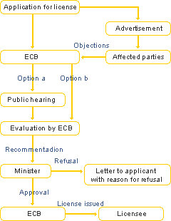

- NamPower is the national power utility of Namibia and specializes in the generation and transmission of electricity. NamPower’s main objectives are the availability, affordability and accessibility of electricity to as many Namibians as possible within the shortest possible time. NamPower's main sources of power are the thermal coal-fired Van Eck Power Station outside Windhoek, the hydroelectric plant at the Ruacana Falls in the Kunene Region, and the standby diesel-driven Paratus Power Station at Walvis Bay. NamPower also has a world-class transmission network. As an electricity company NamPower understands that electricity invariably plays an important role in the socio-economic development of Namibia and is supportive to a number of renewable energy projects in the country such as the Tsumkwe Hybrid Energy project and Combating Bush Electricity for Namibia Development (CBEND) project. Presently, NamPower is the only bulk supplier of electricity. The national utility generates electricity, transmits this via its transmission networks, and also manages all electricity imports and exports to/from Namibia. The electricity supply value chain is shown on Figure 9. NamPower is an essential partner in CSP TT NAM project.

Regional Electricity Distributors (REDs)

- Other actors within the ESI are the Regional Electricity Distributors (REDs), of which NORED, CENORED and ErongoRED are currently operational. The CSP TT NAM Project is earmarked to be constructed either in Erongo Region in the west or Karas Region in the south or Otjozondjupa Region in the central; the Southern RED is pending operationalization. Of importance to the CSP IPP will be the REDs who are the potential off-takers or investors in the CSP TT NAM project.

Figure 9: Electricity Supply (ESI) Industry Value Chain
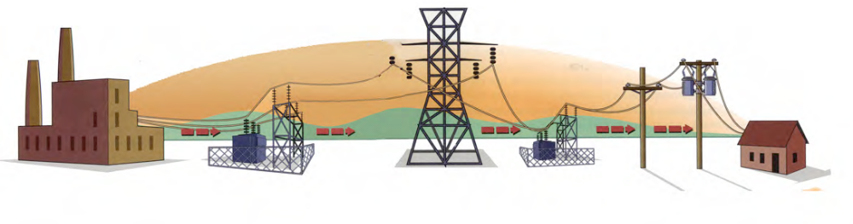
Generation
Transmission
Distribution
Retail

Activities
Operations of power stations and production of electricity, i.e. the 120MW Van Eck coal-fired plant, the 24MW HFO powered Paratus plant and the 249MW Ruacana plant (hydro) | High-voltage, long-distance transmission of electricity between generator and distributor | Regional distribution of electricity from the national grid | Sale of electricity to end users

Local Financial Institutions

- From an international perspective, the large volume for the finance of CSP plants (USD 4 to 6 million/ MW) is often provided by many different institutions such as banks. On the Spanish CSP market, several special purpose vehicles have been founded by a project consortium. Andasol 1 has been financed in the beginning by the companies like Solar Millennium (25%) and ACS Cobra (75%). Later Solar Millennium sold all share to ACS in 2009 after commission of the project. Andasol 3 is in the ownership of the special purpose vehicle “Marquesado Solar S.L.” on which RWE AG, Stadtwerke Munich, Rheinenergie and MAN Ferrostaal and Solar Millennium have ownership. In Algeria, the ISCC plant was also financed by a consortium of the engineering and EPC contractor Abener and Sonelgaz (NEAL). For these first projects, the risk was consequently shared between the project developers and larger investors. The project developers tried to issue a fund to increase their limited financial resources to be able to hold these shares of approximately 25%. After completion of the project, the project development company often sells its share to other owners for the operation. The World Bank and African Development Bank have played a very important role in Egypt and Morocco and GEF has had strong involvment on the financing of CSP plants. Under a feed-in scheme, the risk for private investors and banks is limited if the state guarantees for the payments over 10 to 20 years. When several investors and banks have gained their first experiences with the CSP projects and their rates of return from electricity sales, CSP projects will become more bankable for creditors.

- Within the Namibian context, the availability of suitably structured financing is critical for the commercialisation of CSP project in Namibia. The Development Bank of Namibia (DBN) is the premier provider of development financing in the country. DBN fosters, empowers and finances bold new ventures. Whether large or small, a start-up or expansion, private or public sector, the Development Bank of Namibia generates success, innovation, growth and prosperity. The above arguments emphasise the need for DBN to provide an appropriate incentive framework for the CSP TT NAM concept to get established and thus paving the way for the local commercial banks to involve in financing CSP projects. The commercial banks in Namibia include; Bank Windhoek, NedBank, First National Bank and Standard Bank of Namibia. Of note is that Bank Windhoek has been involved in financing RETs during the NAMREP programme followed by First National Bank for the same programme and the local commercial banks will be receptive on the creation of proper financial conditions for economic viable CSP industry in the country.

Research/Academia Institutions

- Renewable Energy and Energy Efficiency Institute (REEEI) is an institute affiliated with the Polytechnic of Namibia that focuses on the establishment of a national information resource base for renewable energy, sustainable energy use and its management. The REEEI is primarily supported by the Government of the Republic of Namibia. It has a “leadership role in the transition of knowledge from traditional energy sources and usage to a more sustainable energy economy” (www.reeei.org.na) and works in close partnership with the Ministry of Mines and Energy (MME), serving as an information platform. Currently, several projects are being conducted at the REEEI including the NEEP project with its focus on energy efficiency improvement in buildings, and the preparation of a master plan (with MME support) for the provision of electricity in off-grid areas by means of the establishment of “Energy Shops” that will provide access to affordable, sustainable energy technologies, fuels, appliances and services in off-grid and “pre-grid” areas.

- The Institute worked closely with the MME/UNDP funded Namibia Renewable Energy Programme (NAMREP) in addressing various barriers to renewable energy in Namibia. In 2009, REEEI in collaboration with the Transfer Renewable Energy & Efficiency (TREE) project funded by the German Federal Ministry of Environment, Nature Conservation and Nuclear Safety conducted a training seminar in Namibia on solar thermal power plants. The Institute is linking up various Polytechnic of Namibia departments with various organizations for research and development in CSP technologies. Research & development is ordered on a superior level. To bring the technology forward project partners should work together with research institutions.

- The Polytechnic of Namibia (PoN) became an independent educational institution in 1996 with its education programs aligned mostly with Namibia’s industrial demands. The largest faculty is the School of Business and Management followed by the School of Engineering. Along with a number of other technical courses, PoN has centers of learning for “Teaching & Learning”, Entrepreneurial Development, Applied Research and Technology, Business Innovation, and the aforementioned REEEI. In the field of renewable energy, PoN focuses on solar home systems, wind generators as well as the energy efficiency.

- The University of Namibia (UNAM) has its main campus in Windhoek with an additional ten campuses throughout Namibia. UNAM has a faculty for renewable energy located in Ongwediva as of January 2008. UNAM also conducts research in capacity building and training through workshops covering topics such as the development of the research policy, institutional research and strategy implementation.

Industry Representatives

- The Namibian Institute of Architects (NIA) promotes architecture and sound architectural practice among the Namibian architectural profession and general public of Namibia. The NIA is also in close affiliation with the Namibian Council for Architects and Quantity Surveyors. Against this background, the maximal slope of a site for a parabolic trough plant is 2-3°. With excavators the site is flattened to match the requirements of the collectors. The pylon foundations of the collectors require excavations of about 2 meters depth on a square of 2.5 x 2.5 meters. Pylon foundations are individually designed for end pylons, drive pylons, middle and shared pylons as well as in reinforced design for the outer areas of the field, where higher wind loads are expected. Sometimes, an additional wind barrier has to be added to avoid large wind loads or sand pollution of the solar field. Additional civil works includes all construction for infrastructure like roads to the building site or machine houses, assembling halls, engineering offices and logistic centers as a feed stock for material and components. These works are basic construction work and not CSP specific. Therefore, local companies; architects, consulting engineers and surveyors provide this service for the installation of the plant as well as relevant practice documentation, such as contracts.

- Namibia Manufacturers Association (NMA) developed a strategic plan with the vision to facilitate a sustainable, competitive and prosperous manufacturing and processing industry for all stakeholders’ benefit in the country. In the event that a CSP industry is realized in Namibia which involve amongst others; parabolic trough receiver production processes, bent glass mirrors production processes and metal structure production processes, the manufacturers association being the watch dog and mouthpiece of Namibian member manufacturers representing 61 manufacturers, and offering them and others, services to help improving their businesses, the CSP industry present a new opportunity for manufacturers to venture into CSP sector. The on-site jig-assembly, the antireflective coating and galvanization seem to be most likely to be performed in Namibia. On the other hand it is very difficult to give a clear final judgment as a production complex is never based on one single process. Nevertheless, this overview is based on recent production technologies. It is therefore likely that the approach undergoes a continual change, during the development of a competition-based CSP market for Namibia.

- Another important step for Namibia manufacturers are Joint Ventures of CSP companies. To borrow from elsewhere:

‘‘For instance Flabeg erected a whole mirror production in the USA and every German CSP company has a Spanish and American subsidiary to be regarded as a local and not as an intruder looking for government subsidies. A good example is Egypt, where almost the whole erection of the CSP power plant was managed by a local company. As these companies have excellent connections to the state and know the local specifics it was important to include them’’.

- On Table 1 and in accordance with the CSP value chain, early indication shows that local Namibian companies and through the Namibia Manufacturers Association could be potential commercial participants in the CSP market development for Namibia.

- In the final analysis, the participation of local companies in the implementation of CSP projects would potentially reduce the costs of implementation; create new jobs and CSP technology transfer. Table 2 shows the CSP value chain and possible areas of local participation.
- The CSP value chain in Table 2 consists of the CSP core value chain and contains six main phases with varying degrees of participation for local players:

- Project Development: This is the first phase in the implementation of a CSP project. At the beginning the decision-making process with technical and economic feasibility studies, the site selection and financing opportunities provide the basic scope of the project. After a first draft with these basic decisions the conceptual engineering starts with a proposal for the technical specifications. With the conceptual design the permission process and contract negotiations start and these phases will get determined with the financing of the whole project. In current projects engineering experts with specialization on power plant projects offer all the services needed for the project development. Often this phase tends to be the longest due to the fact that feasibility studies, permissions and public decision-making processes take very much time.

- Raw Materials and Components: The second phase of the CSP core value chain is the raw materials and components. Some of them are provided by the world market others are supplied locally depending on costs and logistic aspects. The highly specialized components are supplied mainly by a few international players who have specialized in CSP components such as the trough systems. This is dominated by a few CSP developer companies. Other components such as reflectors, mirrors, reflector film, heat collection element, are supplied by companies in related manufacturing activities but who have added a production line to cater for CSP components. This is a larger group of companies than the specialized CSP developers, but also tend to be large international companies. Other components sourced from this group of companies include those components used in power plant production but not unique to concentrating solar and include natural gas boilers, stream turbines, condensers, and cooling towers. Components such as steel structures, piping, and insulation can be locally manufactured by industries already engaged in related manufacturing activities;

- Plant Engineering & Construction: The fourth phase of the value chain is the plant engineering & construction done by the engineering, procurement and construction (EPC) contractor. The EPC contractor is responsible for the whole plant construction. As project manager he/she selects all the suppliers and awards most of the jobs to subcontractors. As a project manager the main task of the EPC contractor is to coordinate all partners. EPC contractors are mostly subsidiary companies of industrial groups who can resort to building companies and engineering consultants in their own company group.

- Operation: as the fifth phase includes the operation and maintenance (O&M) for several years (up to 25-30 years). The tasks for operation and maintenance can be split into different groups of areas: Plant administration, operation and control, technical inspection of the power block and the solar field operation and maintenance. The task of operations is well suited to local contractors / IPPs to undertake and provides long-term employment opportunities;

- Transmission and Distribution: This is the final step that delivers the electricity from the plant to the consumers. Large utility companies take the responsibility for the distribution (wheeling).

Table 1: Local Companies

Companies | CSP area
Valco Sales & Service CC | pumps, fittings, heat transfer, heat exchangers
Nirosta | Steel, pressure vessels
Pupkewitz Metalworx | very large group of companies, may be able to supply components
Kurose (Pty) Ltd | water, heat exchanger, pipes, tanks
PG Glass | tempered glass
Africa Glass Industries Namibia | tempered glass
Ohorongo Cement (Pty) Ltd | Foundations
Suremix | Foundations
Brick & Concrete Industries (Pty) Ltd | Foundations
City Concrete (Pty) LTD | Foundations
Concretech industries | Foundations
Concrete-Simply In | Foundations
NAMSLAB | Foundations
COASTAL PRECAST & PAVING | Foundations
WIBEKU CC | Foundations
Precast Walls | Foundations
Coupar Contrete (Pty) Ltd | Foundations
Barloworld Concrete Industries | Foundations
Kraatz Steel (Pty) Ltd | Steel structures
Namibia Engineering Corporation | Steel structures
Pro-Edge Steel | Steel structures
Coastal Steel Works | Steel structures
Stainless Engineering | Steel structures
Exacto Engineering CC | Steel structures
Invo Stahlbau CC | Steel structures
Steel & Wire | Steel structures
Steel Force CC | Steel structures
Suresteel | Steel structures
Steeldale Reinforcing & Trading (Namibia) | Steel structures
Aurecon | Engineering
Burmeister & Partners | Engineering
EMCON | Engineering
CSA | Engineering
CMB Namibia Ltd | Engineering
Meyer Consulting Engineers | Engineering
Lithon Project Consultants | Engineering
Windhoek Consulting Engineers (WCE) | Engineering
Danie Nel Consulting | Engineering
Corona Consulting | Engineering
RMB bank | Financial services

Table 2: The CSP Value Chain
Core value chain | Project Development (Namibia & beyond) | Materials (Namibia) | Components (Namibia & beyond) | Plant Engineering & construction (Namibia & beyond) | Generation (Namibia) | Transmission & Distribution (Namibia)
Element of the core value chain | - Concept engineering  - Geographical determination  - Determination of general requirement | - Concrete  - Steel  - Sand  - Glass  - Silver  - Copper  - Salt  - Other chemicals | - Mirrors  - Mounting structure  - Receiver  - HTF  - Connection piping  - Steam generator / heat exchanger  - Pumps  - Storage system  - Power block  - Grid connection | EPC Contractor:  - Detailed engineering  - Procurement  - Construction | - Operation and maintenance of the plant (IPP) | - Utility (NamPower)  - Transport & distribution of electricity (REDs)
Essential partners | Finance & Ownership (Namibia & beyond)
Essential partners | Research & Development (Namibia & beyond)
Essential partners | Political Institutions (Namibia)

Baseline Analysis

- Namibia and the Southern African Power Pool have been experiencing severe power deficits since the beginning of 2008. Namibia has an installed capacity of 393 MW, while having a peak demand of 477 MW (excluding Zinc Scorpion mine) in 2010. The supply deficit has been filled through imports from Mozambique, South Africa, Zambia and Zimbabwe. The inter-connector with South Africa is capable of transmitting up to 600 MW, while the newly constructed High Voltage Direct Current (HVDC) Caprivi Link Interconnector has a capacity of 300 MW and is upgradeable to 600 MW. Electrical energy units into NamPower system from 2007 to 2010 has been steadily increasing from 3,554 GWh in 2006 rising to 3,767 GWh in 2010. Future demand scenarios are shown in Figure 10. When taking the limited national electricity supply capacity of 393 MW into consideration, the figure illustrates Namibia’s precarious electricity supply situation in 2010. Figure 11 gives the breakdown of energy resources while Figure 12 gives energy situation in Namibia.

- Namibia is vulnerable to power supply disruptions since its foreign suppliers are also facing a power deficits. Step loads, largely from increased mining activities, will continue to place pressure on national supplies. To address the current shortfall, MME through NamPower is contemplating a number of generation options as summarised in Table 3.

Figure 10: Namibian Peak Demand Forecast versus Generation
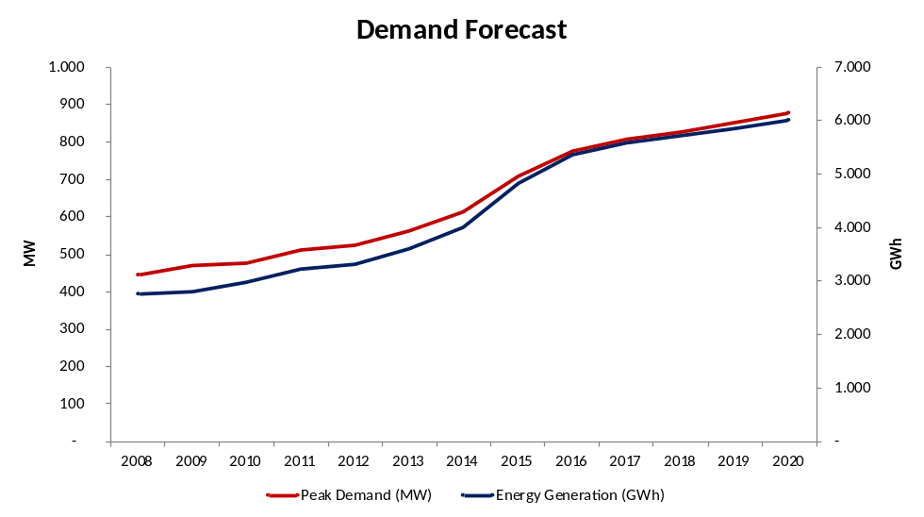
Figure 11: Namibia Energy Consumption by Resource
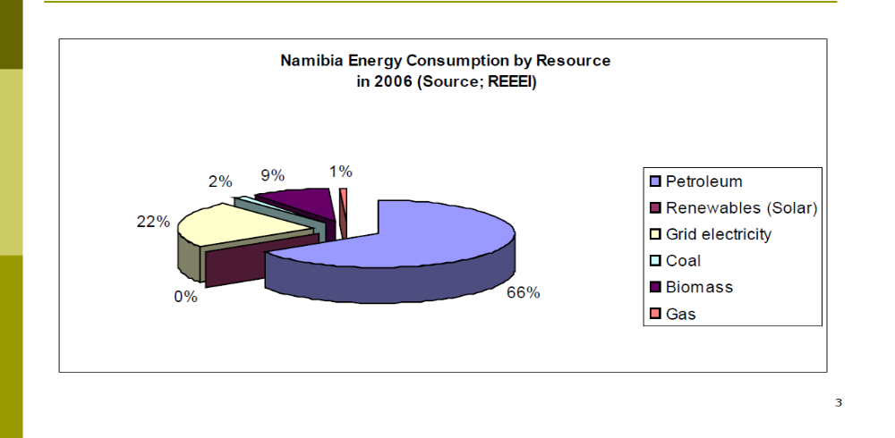

Figure 12: Current Energy Situation in Namibia
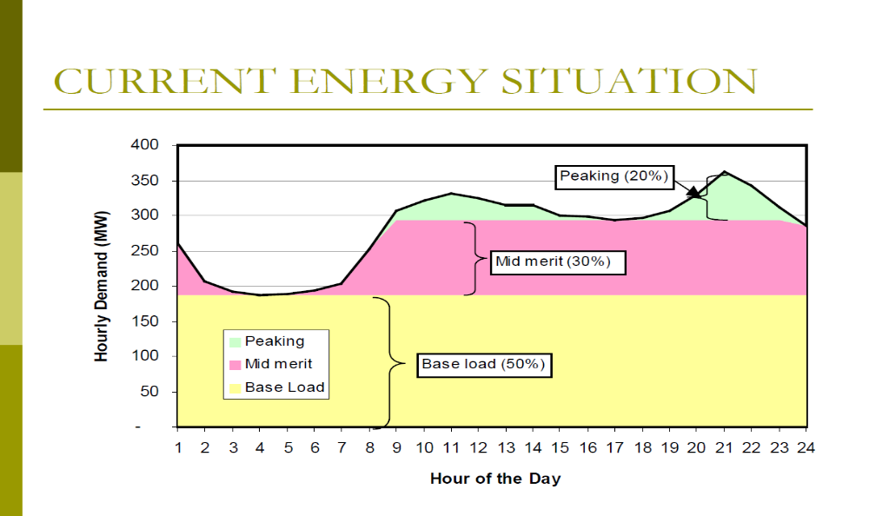

Table 3: Conditional Generation Licenses Issued by ECB
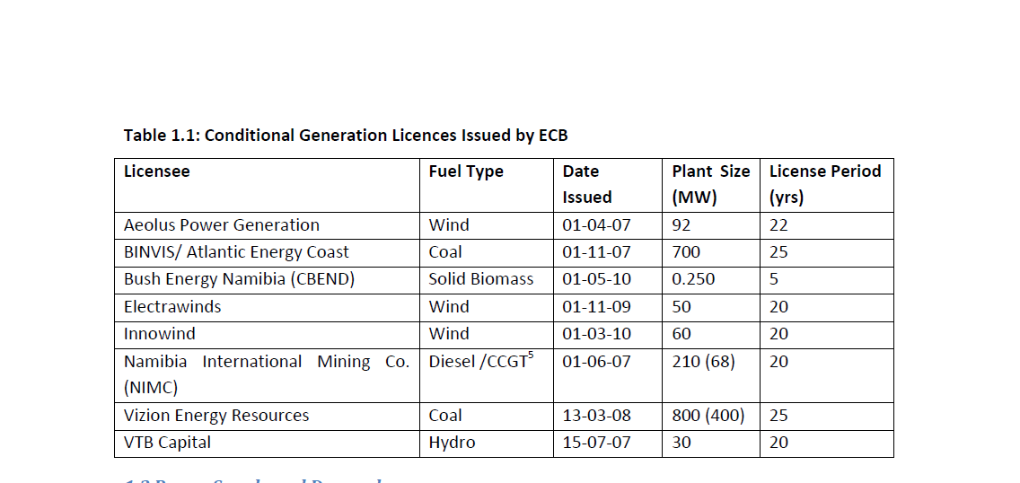

- In 2010, there were 8 IPPs that were conditionally licensed by ECB, intending to generate power from coal, gas, heavy fuel oil, wind, hydro and biomass as shown on Table 4. The licensees are at various stages of negotiating power purchase agreements (PPAs) with NamPower as expected in the single buyer market model. As yet, only Bush Energy Namibia has established an operational power plant (250 kW fuelled by biomass, inaugurated in September 2010), while none of the other licensees has put up any power generation infrastructure.

Table 4: Planned and Status of Power Generation Projects in Namibia
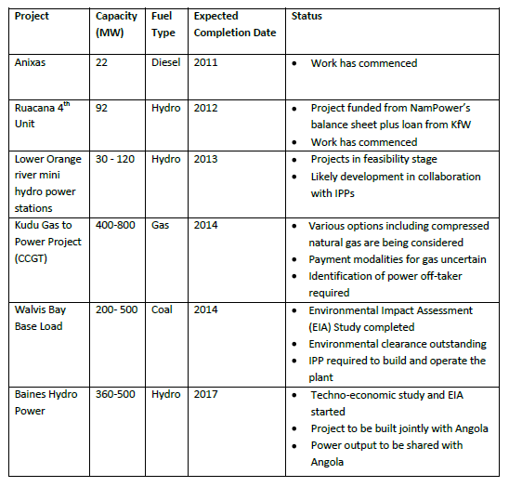
- As mentioned in Para 37, the GRN views CSP as a key technology to bridge the forecasted 2015 energy deficit and are aware through the CSP Pre-Feasibility Study of the actions required to build the requisite capacity and technology transfers to catalyze a local CSP industry. The aforementioned barriers in Paras 46 to 51, however, need to be addressed in order to implement CSP projects to that will mitigate the 2015 energy deficit.

STRATEGY

Project Rationale and Policy Conformity

- Overall, the CSP TT NAM project is set against a background of rising electricity consumption in Namibia coupled with a growing power deficit in South Africa, the country’s main energy supplier. Like most developing countries which are energy importers, the likely increase in future energy costs or disruption in energy supply could jeopardize Namibia’s economic growth. These developments and risks contrast with the limited application of renewable energy and energy-efficient measures and technologies in the country, particularly among local authorities (including the REDs) who are the largest single electricity consumers with the domestic/residential sector accounting for almost 50% of current energy consumption. Measures to promote CSP projects can be expected to improve energy security, and also generate employment and serve as a cost-effective GHG emission reduction option. As part of the historical legacy between Namibia and South Africa, Namibia has inherited South Africa’s energy-inefficient mind-set, technologies, applications and regulations as well as the general lack of awareness regarding the cost advantages of renewable energy and energy-efficient technologies and equipment.

- The project will help Namibia to develop its capacity in CSP technology through a pre-commercial solar thermal plant, which is regarded as one of the cleaner and more mature technologies through south-south and north-south transfer opportunities.

- The project which aims at mitigating the impacts of climate change through the promotion of on-grid renewable energy in developing countries is an element of the GEF-4 Resource Allocation Framework. The project idea responds directly to the GEF aim to promote low-GHG energy technologies, through the increased production of renewable energy in electricity grids.

- The proposed project is relevant to the ongoing MET climate change program, in particular to its efforts to develop a national mitigation plan and support the development of technologies that reduce GHG emissions, including renewable energy technologies (RETs).

Country Ownership

- Climate change is considered one of the most serious threats to Namibia’s environment, human health and well-being, and its economic development. Namibia has ratified the UNFCCC on 16 May 1995 and met its obligation by completing Namibia’s First National Communication (the INC) to the UNFCCC in 2002, and subsequent implementation of Namibia’s Second National Communication in 2010 (SNC). Both the INC and SNC technical and research studies contributed to GHG inventories and identified key vulnerability issues and priority policy measures for Namibia. A policy on National Climate Change was issued in 2010. MET became the national focal point for climate change issues.

- Another action implemented under the national climate change program is the establishment of the Namibia Climate Change Committee (NCCC) in 2001. The NCCC is a multi-stakeholder committee to advice government on the needed policies and strategies to adopt for preparing the country to the predicted and, in some cases actual, effects of climate change. Currently, the committee consists of representatives from the government, NGOs and parastatals such as NamWater and NamPower, private sector representatives and tertiary academic institutions such as the University of Namibia and the Polytechnic of Namibia. The MME has also taken other important steps to improve the performance of the energy sector through its White Paper on Energy Policy. In this policy, the Government of Namibia recognises the importance of RE and EE.

- With the Energy Paper of 1998 and the complementary Vision 2030 approach towards renewable energy, electricity supply has become a major issue for Namibia and indeed the entire SADC Region. The role that the Energy White Paper played in the development of the Namibian renewable energy technologies development cannot be over emphasised as the following extract in Box 1 underpins the Government’s commitment to changing the playing field for the implementation of adequate RE technologies.

Box 1: Government of Namibia Policy on RE

Government will ensure that institutional and planning frameworks treat renewable energy on an equal footing with other forms of energy when assessing their financial, economic and social costs and benefits.
And,
Government will facilitate adequate financing schemes for renewable energy applications, and will encourage government agencies, investors and users to make decisions based on the life-cycle costs of alternative energy options.

- In this context Namibia has quite a long history with renewable energy (RE), energy efficiency (EE), and technology transfer (TT) platforms. The Government of Namibia’s social obligation to electrify rural areas and the need to provide electricity for the rural poor was a major initiative following independence in March 21, 1990. The rural poor population is dispersed over large parts of the country, making electricity grid extensions often not a viable option, hence leading to the development of off-grid platforms. These early assumptions drove government to implement several projects in support of the adoption of renewable RE, EE, and TT solutions. The need to bring rural communities into the mainstream economy saw the initiation of projects focusing on the development of different forms of energy, including from renewable sources.

Country Drivenness

- Namibia is committed to the development of its renewable energy resources as articulated in the White Energy Paper of 1998. The Government further recognizes the important role renewable energy and particularly solar energy can play in the primary energy mix and energy security. Indeed Namibia supported by catalytic resources from the GEF has put concrete measures in place to promote solar energy use. With GEF support, Namibia has made great strides by removing some of the previous technical and institutional and market barriers to successful adoption of RET in the country. However, new innovations and opportunities for development still need to be supported, such as the opportunities for CSP TT. Within the regional context, the development of CSP will add much needed electricity generating capacity towards the objectives of Vision 2030, Namibia’s long-term development aspiration, which aims to develop the country into a knowledge-based fully industrialized country. At the same time, the National Development Plan 3 (2007-12) has set a target for 10% of the national energy demand to be sourced from renewable energy by 2012.

- In the White Paper on Energy Policy (1998), the Government of Namibia recognizes the importance of renewable energy in the country’s energy mix. Further the Government has put in place concrete measures to promote the greater use of solar energy and has successfully managed a large scale GEF supported project that aimed at removing barriers to adoption and promotion of RETs and solar energy technologies (SETs). In particular, this component will support the country’s “Off-Grid Energization Master Plan” which has mobilized financing for the use of primarily solar energy in extending electricity services to off-grid areas.

- In addition, both the Country Program Document (CPD) and Country Program Action Plan (CPAP) 2006-2010 of the Government of Namibia and UNDP identify energy and environment for sustainable development as a key strategic point to support Namibia’s long-term development aspirations. The TT project idea is based on the CPD as well as the UNDP strategic business plans (2008-2011) and directly contributes to the attainment of the Millennium Development Goals (MDGs). The outcomes are linked with the UN Development Assistance Framework (UNDAF) for Namibia 2006-2010, particularly Outcome 4.4, which address capacity development and enhancement to deal with challenging sector environments. Namibia has recently completed an innovative project on a cleaner production program in conjunction with UNIDO. MME is presently formulating the “New Energy Regulatory Framework” (NERF), which will look at governing the approach of renewable energy and energy efficiency market development in Namibia by facilitating fair market access, return on investment, quality of supply, standards, market support structures and incentives and legal issues in Namibia.

- It is expected that CSP TT NAM will provide valuable input to NERF and at the same benefit from a successful energy regulatory framework. CSP TT NAM will benefit from the fact that both executing partners, MME and REEEI, have collaborated in executing REEECAP and are still working together to coordinate both NERF and the Off-Grid Energisation Master Plan (OGEMP).

- This project also builds on the latest efforts of the World Bank Group (WBG) and African Development Bank (AfDB) to pursue a Concentrated Solar Power (CSP) scale up in the Middle East and North Africa (MENA) as well as the CSP Project in South Africa as part of their Clean Technology Trust Fund. The WB and AfDB Regional Investment Plan (www.worldbank.org/cif) to implement a Gigawatt-scale CSP program in the MENA region that will accelerate the global adoption of CSP technology. They note in the Investment Plan that a confluence of factors provides a unique opportunity to provide scaled-up financing for the demonstration, deployment and transfer of a low-carbon technology such as CSP with significant potential for long-term greenhouse gas emissions savings. The South African 100 MW CSP project to be implemented by Eskom with funding from the World Bank, African Development Bank and other donors will serve as another regional scaling up opportunity. Government of Botswana is also undertaking a feasibility study on a 200 MW CSP plant.

- Most recently and importantly, the GRN funded its own pre-feasibility study during the July 2011 to July 2012 period under the auspices of MME, EEP and Polytechnic of Namibia, to determine its best options to ensure the development of sufficient electricity generation capacity to overcome the 150 MW energy deficit forecast for 2015. It also concluded that it will require short-term investments that includes CSP development of 100 MW by 2015.

Design Principles and Strategic Considerations

- The CSP TT NAM Project was designed with extensive inputs from the major line ministries involved with the Namibian White Paper on Energy Policy and its Strategic Action Plan on RE. The Project would address key issues in the government’s strategy to improve institutional capacity for CSP promotion and development, increase capacity of the local private sector to participate in the CSP supply chain, and to develop 100 MW of CSP generation capacity prior to 2015.

- MME is presently formulating the New Energy Regulatory Framework (NERF) which will look at governing the approach of renewable energy and energy efficiency market development in Namibia by facilitating fair market access, return on investment, quality of supply, standards, market support structures and incentives and legal issues in Namibia. NAM CSP TT will provide valuable input to NERF and at the same benefit from a successful energy regulatory framework. NAM CSP TT will benefit from the fact that the implementing partner, MME, and other collaborators like REEEI, have collaborated in executing NAMREP, REEECAP and are still working together to coordinate NEEP, NERF and the Off-Grid Energization Master Plan (OGEMP). Synergies created during the implementation of those national initiatives will be replicated to ensure smooth and timely implementation and execution of work.

- The Project has had key inputs from the recent MME pre-feasibility assessment of CSP completed in July 2012. The activities of CSP TT NAM will be tailored to build the requisite national capacity for Namibia to control its development of CSP projects, and to catalyse the financing, construction and installation of 50 MW of a CSP generation capacity by 2014. These activities are designed to minimize the expected energy shortfalls of 2015. As such, GRN has been specific in terms of its need for assistance from this project that includes:

- Strengthening linkages between local CSP stakeholders and foreign technology partners to the extent that a local CSP technology industry is established;
- Developing a market policy framework that enables GRN to effectively promote CSP technology;
- Preparation of bankable feasibility studies and EIA reports for two promising CSP sites in Namibia;
- Setup of appropriate business models for implementing the initial CSP plants in Namibia.

The outcomes of these actions will be increased capacity of local stakeholders to become involved with the CSP value chain, increased investor confidence through a developed regulatory framework for CSP plant development, and the increased likelihood of raising funds for the design and construction of a CSP plant in 2014.

- The proposed CSP project will build on various project interventions supported by Namibia’s development partners, notably DANIDA, GTZ and GEF, particularly from the TNA undertaken under the SNC as well as various report under the NAMREP projects. In 2007, Namibia under the leadership of MET successfully enacted the Environmental Management Act which provides for compulsory Environmental Impact Assessment (EIA) and Strategic Environmental Assessment (SEA), including the establishment of a conducive and enabling environment for appropriate technologies. Water availability will be a significant factor in siting the first CSP plants since the use of dry cooling technology lowers plant efficiency by an estimated 20%, and is costlier adversely affecting the rate of return.

- UNDP’s previous experience shows that RE programmes are most effective when the process involves all stakeholders from the onset and when all analyses, interactions and decisions are open to full scrutiny by all parties. The CSP TT NAM Project will catalyse development of Namibia’s first Concentrated Solar Power Plant. The GEF’s experience on CSP projects in North Africa points to the lesson that “risks should be shared among all program participants.” The development and implementation of this project will be as transparent as possible, with the active involvement and joint risk-sharing of the government, industry (including equipment manufacturers), Non-Governmental Organizations (NGO), utilities, and technical and professional bodies.

Project Objectives, Outcomes and Outputs/Activities

Project Objective

- The key objective of the proposed project is to increase the share of renewable energy resources in the Namibian energy mix by developing the necessary technological framework and conditions for the successful transfer and deployment of CSP technology for on-grid power generation, thereby reducing greenhouse gas emissions. This would be achieved through:

- Firstly, the establishment of CSP technology partnership agreements between foreign providers and Namibian stakeholders in the private sector, government and academia. In turn, this would contribute to enhanced knowledge of applicable CSP applications in Namibia, and the eventual outcome of local entrepreneurs being engaged in the supply chain for CSP projects being constructed in Namibia;
- Secondly, the development of market policy framework for CSP technology that would lead to the approval of policies supportive of its application and the eventual outcome of increased investments in CSP technology applications in Namibia; and
- Thirdly, the provision of TA for the development of feasibility-level engineering designs, EIAs, business plans and financing agreements for the approved construction and commissioning of a 50MW CSP project. This would lead to the design, engineering, construction and operation of the plant which is expected to result in an increased installed capacity of CSP plants in Namibia via replication projects. This outcome will improve the confidence of the government and citizenry on the techno-economic viability of CSP with the completed CSP project serving as a template for subsequent CSP projects in the country.

Overall, these outcomes are expected to be realized considering the current rise in electricity consumption and prices in Namibia and the power deficit in South Africa, the country’s main electricity supplier. The subsequent threat to the country’s economic growth, and the vulnerability to developments in South Africa, contrasts with Namibia’s sufficient solar resources and a demonstrated need for additional generating capacity.

- The project will consist of three components, each of which has expected outputs and a number of specific activities planned to achieve them.

- Component 1: CSP Investment Partnerships in Namibia. CSP technology is still confined to a few players in the world in Germany, Israel, Italy, Spain, United States of America and other developed countries with active applied research. To bring some of these players into the Namibian CSP market, a recent scoping and due diligence analysis of global players had been done using some of the networks created through the CSP Pre-feasibility Study and TREE project CSP Seminars. However, to realize growth in the number of CSP players in the Namibian market in concert with the GRN’s power generation expansion plans to 2015, concerted efforts are required to accelerate local CSP investment through focused knowledge transfers and increased number of meetings between foreign and local players. This growth of interest in CSP needs to be facilitated in a systematic manner, covering local businesses that are equipment suppliers to installers, project management and engineering service providers to financers. Once this interest has been established through capacity building workshops and conferences to catalyse business links between local and foreign firms, a number of CSP partnerships can be finalized through memoranda of understanding that would facilitate TT. These efforts can be accelerated associations such as Namibia Manufacturers Association and the Namibia Institute of Architects. The expected outcome from the deliverables under this component is local entrepreneurs engaged in the manufacturing, supply and installation of CSP systems:

- Output 1.1: Finalized technology partnership agreements. Activities leading to the delivery of this output includes:

  - Scoping and due diligence analysis of global CSP players using some of the networks created through the CSP Pre-feasibility Study and TREE project CSP Seminar;
  - Formulation and establishment of partnership MOU agreements with at least two partners: South- South and North-South to facilitate technology transfer;
  - Establishment and operationalization of a National Technology Transfer Coordinating Body (NTTCB).

GEF support is required to augment the current scoping and due diligence analysis of global CSP players through the network of UNDP and international project personnel; formalizing the due diligence process for global CSP players; facilitating linkages between foreign CSP players and local businesses through expositions and workshops; facilitate MOU agreements between foreign and local partners; and setting up an operational NTTCB in collaboration with MME and other relevant government agencies.

- Output 1.2: Enhanced knowledge of applicable CSP applications in Namibia. To support nascent and ongoing CSP knowledge transfers within PoN and REEEI, a focused capacity building programmes will be required that targets policymakers, engineering consultants, equipment suppliers and manufacturers, construction contractors, and financing institutions. This will develop a broad base of participation of local players, and provide to them the necessary knowledge to justify further investments that will enable them to be a participant in the local CSP supply chain. Topics to be covered within the capacity building programmes will include energy policy and planning; CSP project design, development and operation; resource assessment and analysis; technical and manufacturing requirements of related CSP industries; and financial and economic evaluation of CSP projects.

GEF support for the delivery of this output is required for:

  - Conducting a capacity needs assessment;
  - Designing and setting up a curriculum to address capacity needs with topics ranging from energy policy and planning to manufacturing requirements of CSP industries and financial and economic evaluation of CSP projects. The curriculum will be based on targeted groups for capacity building such as policymakers within the Renewable Energy Division of MME and REEEI, and for practitioners in private sector and manufacturing industries;
  - Delivery of CSP capacity building workshops by knowledgeable professionals; and
  - Collecting feedback on the effectiveness of the workshops by the participants, and improving the subsequent workshops based on the feedback.

- Component 2: Policy Frameworks for CSP Initiatives in Namibia. While Namibia currently does not have any supportive policy framework to encourage CSP investments, it recognizes that such a framework is required to avert predicted shortfalls in its future generation capacity. Direct policy instruments are required to support CSP market development in Namibia that includes both financial and non-financial measures. The financial measures would provide financial incentives to market parties to facilitate CSP investments. Non-financial measures would raise the interest of potential investors into the CSP market through increased levels of understanding of the available solar resources, facilitating business relationships between potential CSP suppliers, service providers and financers. From the expected outputs under this project component, the expected outcome is increased investments in CSP technology applications in Namibia:

- Output 2.1: Investment grade solar resource data: Currently, MME has satellite information on solar irradiation, and no operating ground level solar radiation metering stations. Ground level solar irradiation information is required to measure the actual solar irradiation levels at potential CSP project sites; this is important considering the sensitivity of irradiation to aerosols at different locations due to topography, variable cloud cover and unique weather patterns. Moreover, with the projected high capital investment of the proposed CSP projects, potential CSP sites do require solar resource data to be “investment grade” through this thorough analysis as this will provide more confidence on the project rates of return. The July 2012 Pre-feasibility Study for the Establishment of a Pre-Commercial CSP Plant in Namibia provided its top 5 CSP sites for further development that includes the collection of investment grade solar resource data. To date, these sites only have satellite solar data that need correlation with ground solar measurements. Assistance is required to analyze the combination of accurate ground measurements and long-term satellite data including site-specific correlations of at least one year that is recommended for sites where there is no available high quality long-term irradiation data. GEF support is required to:
  - Select suitable ground measurement spots that are less than 3 km from the 5 top CSP sites in Namibia as determined by the July 2012 pre-feasibility report funded by MME ;
  - Finalize the site to be selected for initial CSP development through consultation with all stakeholders. At this time, the Ausnek, Kokerboom or Gerus sites appear to be the most promising 50 MW CSP sites;
  - Prepare plans for the continuance of ground solar measurements at other promising CSP sites; and
  - Carry out ground measurements for the 5 top CSP sites in Namibia over one year. Ground measurements will augment the available and less accurate satellite data.

- Output 2.2: CSP planning and implementation mechanisms established within MME. This output essentially provides further support for the July 2012 pre-feasibility study funded by MME on the suitability of CSP technology throughout Namibia. The study also ranked 40 CSP sites (of which 5 are to be selected for ground measurements in Output 2.1) in terms of their direct normal radiation (DNI), temperature, access and slope as well as access to the electricity grid and water availability. The output will also support MME in its efforts to promote CSP technology including its application with existing fossil-fuel and renewable electricity generation plants. This output will be delivered by two main activities: (i) preparation of detailed information (to a reconnaissance level) of the most promising CSP sites that should include hybridization options with natural gas, coal and biomass; and (ii) conducting a policy dialogue with national stakeholders according to a working agenda agreed upon with partner organisations;

GEF support is required for the preparation of reconnaissance level reports for the 40 most promising CSP sites (with sufficient information to interest potential investors), and workshops and conferences to facilitate policy dialogue on accelerated development of CSP projects in Namibia based on the reconnaissance level reports.

- Output 2.3: Approved and enforced regulations for promoting development and operation of CSP plants in Namibia: These regulations will essentially provide confidence to potential public and private investors of the soft costs required to develop CSP projects in collaboration and under the auspices of the GRN. Delivery of this output will require: (i) ranking of the best CSP technologies and their reference costs based on the July 2012 MME Pre-Feasibility Study; (ii) identification of financial incentives and options for local financing institutions with regards to risk mitigation for CSP investments; (iii) defining the legal status of a private CSP operator in the modality of an IPP; (iv) a resolution regarding land tenure and water use rights for CSP projects; (v) regulation concerning environmental constraints and management of CSP areas; (vi) creating streamlined procedures for permits and concessions for CSP electricity generation and distribution; and (vii) guidelines for the financing and development CSP projects and requirements for monitoring of these projects that would include close involvement of DBN and other local financial institutions.

GEF support is required for technical assistance in the ranking of the best CSP technologies and their reference costs, drafting of the aforementioned technical regulations to the extent that they are accepted, approved and used for promoting development of CSP plants in Namibia.

- Output 2.4: “High precision" stations or RSI (Rotating Shadowband Irradiometer) stations in place for remote sites to obtain investment grade solar resource

To facilitate CSP investments within the GRN’s 2015 timeframe for the expansion of power generation sources, GEF resources assistance will be required to purchase appropriate instruments that will provide the required on-site ground measurements using appropriate measurement systems that would include either “thermopiles” or “rotating shadowband irradiometers (RSI) stations” as well as long term satellite solar irradiation data.

- Component 3: Facilitation of the first CSP plant in Namibia. This component will support activities that will facilitate the securing of project finance and the construction and implementation of a 50 MW CSP plant. Expected outputs towards this outcome are the bankable feasibility study and the environmental impact assessment, both crucial documents that will increase lender confidence on the planned CSP projects, their costs, rates of return and the environmental impacts. With the construction of the first CSP plant, expected outcome from this project component is the increased installed capacity of CSP plants in the country:

- Output 3.1: Completed feasibility study of selected CSP site: This output will support the preparation of a bankable feasibility study and financial model that will provide sufficient CSP project details of the Ausnek, Kokerboom or Gerus sites for the approval of financing of these projects. MME will coordinate activities to deliver this output including:

  - Validation of CSP technologies to be deployed on site including solar technology (tower or trough), cooling system (wet cooling or dry cooling) and storage system based on solar technology selected;
  - Setting up and utilization of a thermodynamic model for a selected plant configuration to optimize generation of electricity. The model will be built from a software package for CSP projects (such as the privately developed SunBD model or the NREL-developed SAM model) and can be used for future operations by plant owners and operators to determine plant electricity outputs with more precision and confidence;
  - Finalization of the plant configuration prior to a detailed engineering phase using model results. This will involve optimization of the plant layout, and specific locations of the heliostat fields, heat exchanger, heat storage, and power plant;
  - Incorporation of field information into project design that may include specific geological information for foundations, and identification of areas with optimal DNI;
  - Formulation of a rough implementation plan that will include equipment procurement, site preparation, equipment installation, commissioning and O&M
  - Full financial model, including determination of plant revenue streams and rates of return, as well as recommended optimal capital structure.

GEF support is required to prepare the terms of reference for selection of a qualified engineering team, setting up the thermodynamic model, finalization of the plant configuration, CSP plant economic and financial analysis, formulation of the rough implementation plan, and completion of the feasibility study and implementation plan that will comply with international standards for such studies.

- Output 3.2: Completed environmental impact assessment: Completion of an EIA report will be a condition to obtain the necessary environmental permits and concessional financing from donors and government development banks. As such, the report will need to comply with EIA standards of various IFIs such as the World Bank as well as the Namibian environmental regulations. MME will coordinate activities towards the realization of this output that will include:

  - Comprehensive review of existing legislation, policies and guidelines;
  - Identification and establishment of the baseline conditions (physical, biotic and social/cultural);
  - Definition of the main project components of CSP;
  - Assessment of potential impacts (social and physical) during construction and operation;
  - Development of a suite of appropriate mitigation and enhancement measures;
  - Development of a plan for public consultations; and
  - Development of an Environmental and Social Management Plan, including a Monitoring Plan.

GEF support is required to prepare the terms of reference for selection of a qualified environmental team to complete the EIA study in parallel with the bankable feasibility study that will comply with IFC or World Bank standards for such studies.

- Output 3.3: Approved institutional, financial and business arrangements for initial CSP plant development: To facilitate the financing and implementation of a CSP plant, business arrangements need to be completed and approved between the GRN, NamPower (the proposed implementing agency) and private equity groups. Due to the expected USD 250-300 million price of a 50 MW CSP plant, a suite of financing business arrangements needs to be developed. The July 2012 pre-feasibility study recommends that MME should undertake preliminary conversations with the Ministry of Finance and other state agencies to understand the risks resulting from a sovereign guarantee for this CSP project. Furthermore, the study recommends that NamPower and the Development Bank of Namibia (DBN) take an equity stake in the project with the debt portion being arranged with a sovereign guarantee. GRN will also encourage offers from the private sector for equity positions of the first CSP plant. MME will coordinate the following activities required to deliver this output including:

  - Setup a special purpose entity (SPE) dedicated towards engineering, constructing and operating the initial 50 MW CSP plant that will offset risks to NamPower and provide a platform for private equity of the CSP plant. The SPE will setup REEEI as the Project Management Unit (PMU) that will provide overall project management and monitoring according to GRD and IFI rules and regulations;
  - Design specific financial mechanisms to finance the first CSP plant through the SPE with concessional financing from development banks and private equity. The financial mechanism will likely contain a negotiated fixed tariff, debt incentives and tax exemptions;
  - Development of specific plans for improving MRV capacity within the SPE and the feasibility of accessing specific carbon funds (building onto Output 2.4). Existing or planned technical assistance and carbon funds that may be available to the CSP developments will be explored pending the ability of the CSP project development group to monitor, report, and verify their GHG emissions to an international standard.

GEF support is required to assist MME to facilitate support from NamPower and ECB for their involvement in the 50 MW CSP project; facilitate discussions with MoF, DBN and IFIs on sovereign guarantees and equity stakes on the CSP project; set up the SPE and financing arrangements for implementation of the CSP project; and strengthen capacity of the SPE to monitor and report GHG emissions to an international standard.

- Output 3.4: Signed EPC contract and commencement of CSP construction: With the securing of financing of the initial CSP plant through the SPE, construction of the CSP plant will need to be executed through an engineering-procure-construct (EPC) contracting arrangement. To secure the services of the EPC contractor, detailed engineering drawings and a construction and implementation plan need to be prepared for the EPC tender documents. Once the EPC contract is signed, construction can commence for the initial CSP plant. Activities required to deliver this include:

  - Preparation of detailed engineering plans with sufficient detail for an EPC contractor to prepare tendered bids for CSP plant construction;
  - Preparation of an EPC tender and contract that will foster participation of local companies in the supply chain (i.e. supply of technology, engineering, financial, technical and managerial services) for constructing the 50 MW CSP plant;
  - Obtaining all legal permits;
  - Setup tendering process for the construction of the CSP;
  - Opening of tenders, and negotiating and signing the EPC contract; and
  - Preparing and managing implementation plans for constructing the CSP plant.

GEF support is required for senior oversight to the preparation of detailed engineering plans for the EPC tender and contracting process; negotiating and signing of the EPC contract; preparation of implementation plans; and senior oversight to the management of implementation.

- Output 3.5: Workshops to disseminate lessons learned in the development of the 50 MW CSP plant. This will be done for the benefit of other private and public entities interested in financing and developing other 50 MW CSP projects that replicate the first CSP investment.

GEF support is required for the arrangement of the workshops and the preparation and dissemination of the workshop proceedings.

- Figure 13 provides an illustration of the interrelationship between the various components of the CSP TT NAM Project. The overall project outcome will be a scenario where financing for a 50 MW CSP can be secured based on the completion of a thorough feasibility study of the CSP projects, the finalization of a business and financial model on which to implement these CSP project, the emergence of a market policy framework on which government can support its promotional efforts for CSP development in Namibia, and the increased confidence of the private sector in Namibia to participate with foreign technology leaders in CSP development in Namibia.

In the case in this project and given the urgency of moving forward with the financing and construction of the 50 MW CSP plant as soon as possible the financial framework for the first CSP Plant will depend on the recommendations of the full f/s and will be prioritized based on the most rapid route to deployment and cost considerations. Nonetheless it is fully expected that whatever specific contractual arrangements and financing mechanisms used for this project will be mainstreamed into the REPM efforts and that collaboration will be sought between activities under this project and REPM so that broader financial barriers are removed for the long-term benefit of the RE industry and sustainable future replication of CSP plants.

- CSP TT NAM has been designed as a 3-year project to achieve the Government’s goal of increasing the CSP installed capacity in Namibia prior to the end of 2015. As such, the aforementioned activities have been designed to be supportive towards achievement of this goal. Critical path activities of CSP TT NAM includes the generation of investment-grade solar data (Output 2.1), feasibility and EIA reports (Outputs 3.1 and 3.2), senior oversight to detailed engineering for EPC tender drawings (Output 3.4), and the tender process leading to a signed EPC contract (Output 3.5). Through the timely completion of these activities, construction of the first CSP plant in Namibia would commence prior to the EOP or the end of 2015. The sequencing of Project activities is illustrated in Figure 14.

Figure 13: Flowchart of Activities during Project Implementation
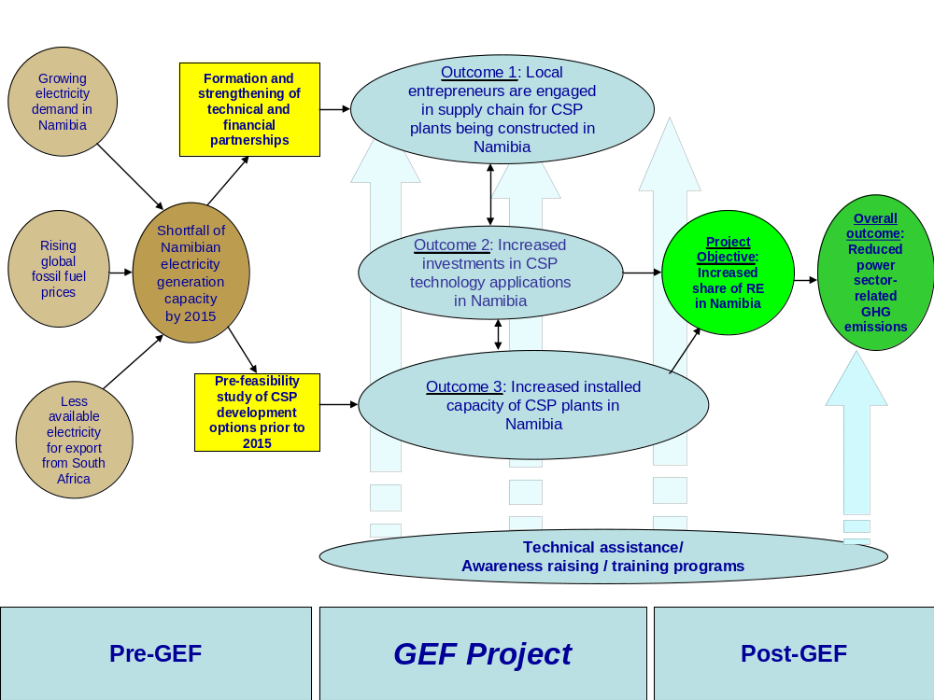

Figure 14: Project Schedule of Activities
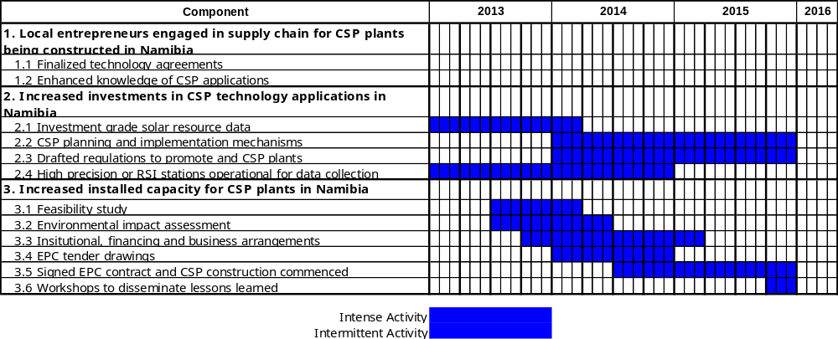

Key Indicators, Risks and Assumptions

INDICATORS

- The most direct impact of the project as it relates to core GEF objectives is the reduction in CO2 emissions from the power sector in Namibia. Associated impacts such as (i) increased access to clean energy in Namibia and, (ii) a transformed local market for CSP technologies and practices will contribute to the overall sustainability of the project and are thus critical to the continued reduction in nationwide CO2 emissions.

- The following indicators are an estimate of the impact of the CSP TT NAM Project:

- Cumulative direct post-project CO₂ emissions (assumes a 10-year influence period of GEF interventions);
- % share of CSP in the power generation mix of Namibia;
- Number of government-endorsed CSP partnerships established;
- Number of local CSP engineering design firms with CSP design experience established and operational;
- Number of local CSP-related manufacturing, supply and installation companies;
- Number of sites where investment grade solar resource data is available;
- Number of CSP investments facilitated by the CSP development guidelines;
- Number of planned and approved CSP technology application projects that are funded by local financing institutions;
- Number of CSP investments supported by carbon finance;
- Number of planned, approved and financed CSP projects that replicate the first CSP investment; and
- Cumulative installed power generation capacity from replicated CSP plants.

Detailed indicators are provided in the Project Results Framework.

Risks and Assumptions

- The overall project risk is moderate. While all possible efforts have been made in the design of CSP TT NAM to mitigate perceived project risks, there are inevitably some unavoidable residual risks that will have to be carefully monitored and managed to ensure project success. Recommended mitigation measures are provided in detail in the “Offline Risk Log” in Annex 1.

Financial Modality

- GEF resources will be used as technical assistance to remove barriers and catalyze financing of CSP projects, and to support activities that will sustain the development of CSP. As such, GEF resources will be used to:

- Strengthen relationships between international CSP technical experts and suppliers and Namibian CSP practitioners and service providers;
- Assist government policies towards the promotion and development of CSP projects in Namibia;
- Prepare the necessary documentation of CSP projects that will increase confidence of financial and lending institutions towards the first CSP projects; and
- Assist project stakeholders to determine the optimal business arrangements and financial frameworks for implementing the first CSP projects in Namibia.

- As the Project will be a NIM implemented project, financial modality will be direct agency implementation (i.e. not cash being transferred to the implementing agency). Under this modality, the MME will still maintain full programmatic control of the Project.

Cost Effectiveness

- The GEF Alternative Scenario would result in a rapid increase in renewable electricity generation, especially from CSP technologies as developed by qualified Namibian professionals with financial support from local institutions. The learning-by-doing approach to be adopted by this project will create confidence amongst the local players so that future CSP technology deployment will have a larger local component, thus increasing the cost effectiveness of the technology. CSP is of particular interest to utilities because it is lower cost and more scalable than, for instance, photovoltaic technologies. Thus, the critical involvement of NamPower reduces the uncertainties over power purchase agreement policies and the adequacy of transmission infrastructure; this will subsequently reduce the cost of capital on an investment where the IRR is low. Specifically, plant costs will be significantly reduced at a proposed plant location, where a turbine generator with a capacity of approximately 24 MVA will be connected to an existing substation with the same adequate voltage level close to the solar plant site. Meanwhile, the comparatively reduced terrestrial footprint of the parabolic trough (land required by CSP plants per MW of installed capacity) and the tower technology versus other CSP technologies (e.g. dish-engine), as well as the shorter lead time of implementation, will translate into significant cost reductions (levelized cost of energy).

- The proposed project is expected to tentatively realize:

- Under a base case scenario (with storage) direct post-project emission reductions of 177,583 CO₂ per year, resulting from the investment in one 50 MW CSP commercial plant leading to substitution of an estimated 175 GWh per year of fossil fuel based electricity (depending on load factor and storage capacity). The estimated unit abatement cost (base case) considering the US$ 1.7 million GEF contribution to this project is about USD 0.36/tonne CO_{2eq} based on a 10-year cumulative GHG emission reductions of 4.79 million tonnes CO_{2eq} from three CSP projects implemented over the next 3 years after the end of the Project;
- Under a low end case scenario (without storage) direct post-project emission reductions of 88,791 tCO2 per year, resulting from the investment in one 50 MW CSP commercial plant. The 10-year cumulative GHG emission reductions from three CSP projects implemented over the next 3 years after the end of the Project would be 2.40 million tons CO2eq (without storage). See Annex E for more information on the two scenarios.
- CSP is a technology that can be deployed as a decentralized power source at several locations in Namibia. Namibia being a vast and sparsely populated country providing power for development in remotely located areas of the country. This in itself will contribute to attainment of various MDGs targets, including ensuring environmental sustainability, reducing poverty and promoting education for all;
- International partnerships in a CSP pre-commercial plant will allow the nascent Namibian CSP industry to become familiar with the technology and local capacity will be built paving the way for a future competitive CSP market. This will result from the training workshops and symposiums on CSP technology held by REEEI and its partners such as Fraunhofer ISE and Lahmeyer International;
- CSP technology is modular and its components can largely be manufactured from conventional materials using well-known and proven technologies. This presents the potential for the technology to be absorbed and adapted by local industry leading to more effective technology transfer practices. Taking a two-step process whereby the initial project implementation phase will focus on setting and codifying the appropriate market, regulatory and set-up environment, will ensure that the technology to be transferred will be sustainable in the long-term, and not only end as a demonstration project. Despite past global experience, a significant take-off of this market is expected nationally and regionally, with the consequent reduction in GHG emissions. The proposed 50 MW CSP project will have a far-reaching impact;
- Namibia’s potential for greater manufacturing and innovation will be developed into a vibrant and dynamic renewable energy private sector industry. The Renewable Energy and Energy Efficiency Capacity Building (REEECAP) study funded by DANIDA on the Electricity Supply and Demand Management Options for Namibia identified that a mix of electricity generation options including CSP would be the best strategy to avert the imminent power shortage and increase energy security in the country. This study, together with other REEECAP studies, also identified solar, biomass and wind energy development as the best low carbon energy options for Namibia.

Sustainability

- From a technical point of view, the viability of grid-connected CSP electricity generation has been proven in the international market, both in the context of developed and developing countries. By addressing the non-technical barriers that impede the development of CSP on-grid electricity generation in Namibia, the project will assist in creating a sustainable niche through strengthening the policy, institutional, legal, regulatory and operational capabilities of the key national institutions, supporting the development of on-grid and off-grid CSP through a market-driven approach, developing national capabilities and disseminating information. These efforts should ensure the long-term sustainability of CSP on-grid and off-grid electricity generation in the country.

- Since the proposed GEF project comprises a strong capacity building element, the main outputs of this project will not only be new CSP partnerships, but also enhanced institutional capacity to effectively maintain energy saving services and revise the regulatory and policy framework over time. The project will specifically focus on addressing issues related to awareness barriers by increasing institutional capacity and awareness as well as providing information on CSP technologies to improve the knowledge of the existing opportunities for thermal power generation technologies and practices, for the private sector (e.g. contractors, equipment manufacturers, service providers) and relevant government agencies. The project will also promote sustainability by training Namibian professionals on CSP technologies and catalyzing a new market in which they will be able to use their acquired knowledge. Similarly, raising awareness on CSP products and projects in the financial sector will enable financial institutions to become more familiar with the intricacies of CSP financing and develop appropriate financial tools for the industry.

- From the financial perspective, the project will first assist in the development of an appropriate procurement policy structure for installed capacities above 50 MW. This will introduce more transparency by developing a competitive institutional model for the award of CSP projects. Furthermore, the project will support the integration of local industries into the CSP sector. This will be achieved through the provision of focused support to local engineering firms and specialised engineering workshops for the installation, operation, maintenance and repair of PV equipment. With the increase in on-grid CSP installations, it is envisaged that such efforts will intensify with opportunities being created for additional players to provide such services.

As already noted while the specific financing arrangement for the 50 MW CSP plant will be decided based on the outcome of the feasibility study, it is fully expected that whatever specific contractual arrangements and financing mechanisms used for this project will be mainstreamed into the GRN’s broader efforts to establish transparent RE procurement mechanisms under REPM and that collaboration will be sought between activities under this project and REPM so that broader financial barriers are removed for the long-term benefit of the RE industry and sustainable future replication of CSP plants.

Replicability

- The project strategy is to catalyse construction of a CSP plant and to provide conditions that will result in the replication of CSP investments in Namibia. To maximize replication potential for CSP investments in Namibia, CSP TT NAM will facilitate the creation of the basic enabling conditions necessary to catalyze private sector participation in the program and to maximize their involvement of local entrepreneurs in the CSP supply chain of these projects. With these built capacities and a suitable regulatory framework in place, there will be a higher likelihood of replication and successful implementation of the future CSP projects. More specifically, the following scenarios will be realized by the end of the project:

- A fiscal and regulatory framework will be in place with (i) national targets for CSP deployment; (ii) concessionary financing arrangements; (iii) investor incentives for CSP; (iv) standardized PPAs for CSP; (v) IPPs championing CSP development that will attract more players and investors to CSP development in Namibia;
- A national solar resource assessment and CSP site identification programme will be in place. This will include programmes for improved solar resource data acquisition and reconnaissance-level CSP site assessments that will be accessible to potential investors and project promoters maintained by REEEI and MME;
- Appropriate business models for CSP projects will have been setup within the framework of new CSP fiscal and regulatory mechanisms. These mechanisms will include market-based financing instruments that will address the high up-front costs of CSP investments;
- Awareness of policymakers and the private sector will have been raised on CSP investment opportunities as a result of training on CSP technical issues, CSP project management and financing aspects;
- One CSP project will have been designed and be under development. This initial CSP investment with key technology partners and local industry participants will demonstrate the potential of market-based financing instruments and regulatory and investment framework for promotion of CSP projects. Linkages will be established between this initial CSP investment and national level agencies to maximize the guidance benefits of this project. Linkages with national level policymakers will also be established to ensure lessons learnt during the implementation of the project will inform the policy review process.

- A SWOT analysis is provided on Table 5 as a guide to building the capacity of Namibia industrial players to take on CSP technological challenges.

Table 5: Strengths, Weaknesses, Opportunities, Threats

Value chain | Strengths | Weaknesses | Opportunities | Threats
Project Development | Many leading engineers and ESCOs in the country have a strong background to technology know-how in RE | Dependency on  political support | Various RE projects are in the pipeline which could trigger CSP development in the country | Barriers exist to markets entrants and high costs of CSP projects
EPC Contractors | Namibia possesses a network of suppliers in RE sector which could be replicated for CSP TT | Price reduction for the CSP projects in the CSP construction market is a challenge in the country | Cost reduction in CSP technologies | Price competition from the international market
Parabolic mirrors | High margins | Cost of setting up new factory | New CSP markets and barriers for market entrants | Flat mirror technology
Receivers | Strong market position | Dependency on  CSP market | Increase of size and  efficiency | Low market demand and limited skills base
Metal support structure | Experience and new business opportunities for structural steel | High cost  Competition | Increase of efficiency and size | Alternative materials

PROJECT RESULTS FRAMEWORK

This project will contribute to achieving the following Country Programme Outcome as defined in CPAP or CPD:
CPD 2006-2010: By 2010 improved environmental living conditions and sustainable use of energy in Namibia, and establishment of sustainable living conditions in the poorest provinces.
Country Programme Outcome Indicators: % of renewable energy used in Namibia
Primary applicable Key Environment and Sustainable Development Key Result Area (same as that on the cover page, circle one): 1. Mainstreaming environment and energy OR
2. Catalyzing environmental finance OR 3. Promote climate change adaptation OR 4. Expanding access to environmental and energy services for the poor.
Applicable GEF Strategic Objective and Program: GEF-4 CC4 Strategic Program SP3: Increased production of renewable energy in electricity grids
Applicable GEF Expected Outcomes: Total avoided GHG emissions from on-grid RE electricity generation
Applicable GEF Outcome Indicators: Market penetration of on-grid renewable energy (% from renewables); GHG emissions from electricity generation (tons CO_{2eq}/ kWh); and $/ tons CO_{2eq}

Outcomes | Objectively Verifiable Indicator | Baseline | Targets | Source of Verification | Critical Assumptions
Project Objective  To increase the share of renewable energies in the Namibian energy mix by developing the necessary technological framework and conditions for the successful transfer and deployment of CSP technology for on-grid power generation | - Cumulative direct post-project CO₂ emission reduction resulting from the investment in CSP by end-of-project (EOP), Mtons CO₂.  - % share of CSP in the power generation mix of Namibia by EOP | - 0  - 0 | - 5.83  - 10 | - Project final report as well as annual surveys of energy consumption & reductions for each CSP pilot project. | - Economic growth in the country will continue  - Government support for RE development and utilization will not change
Outcome 1:  Local entrepreneurs are engaged in the manufacturing, supply and installation of CSP systems | - Number of government-endorsed CSP partnerships established by Year 3  - Number of local CSP engineering design firms with CSP design experience established and operational by Year 3  - Number of local CSP-related manufacturing, supply and installation companies by Year 3 | - 0  - 0  - 0 | - 5  - 7  - 10 | - Approved partnership agreements between local companies and foreign CSP companies  - National TT Coordination Organization approved and in place  - Knowledge products including:  - Report on potential CSP technologies and socio-economic impact monitoring  - Study of technical and manufacturing requirements of related CSP industries  - Report on policy instruments, standards, financial incentives, and financial and economic evaluation of CSP  - Proceedings from the capacity building workshops | - Technical resources are available in MME and REEEI to guide establishment of a coordination body and development of reports  - MME and REEEI staff are willing to commit sufficient time for meeting and developing CSP agreements  - Government staff is willing to commit sufficient time for identifying the needs of different stakeholders to develop different policy instruments, standards, and financial incentives to encourage CSP.  - Government staff is willing to commit sufficient time for participating in training activities and deepen their knowledge on CSP.
Outcome 2:  Increased investments in CSP technology applications in Namibia | - Number of sites where investment grade solar resource data is available by Year 2  - No. of CSP investments facilitated by the CSP development guidelines by Year 3  - Number of planned and approved CSP technology application projects that are funded by local financing institutions by EOP | - 0  - 0  - 0  - 0 | - 5  - 1  - 2  - 2 | - Report on solar resource assessment correlated with ground measurements and a determination of the best CSP site that will developed as the first CSP investment project in Namibia  - Drafted guidelines for CSP development for potential investors complete with reconnaissance-level CSP sites and strategic actions and policies on CSP resource development, ranking of CSP technologies, financial incentives, legal status of an IPP, environmental and management of CSP areas, and streamlined procedures for CSP permits and concessions on land tenure and water rights | - Investment grade solar resource data is made available to potential CSP investors  - All stakeholders needed for technical or financial resources are available to enable the achievement of the project objective  - Government staff is willing to commit sufficient time for identifying the needs of different stakeholders to develop different policy instruments, standards, and financial incentives to encourage CSP
Outcome 3:  Increased installed capacity of CSP plants in Namibia | - Number of planned, approved and financed CSP projects that replicate the first CSP investment by EOP  - Cumulative installed power generation capacity from CSP plants by EOP, MW  Set of regulations promoting the development and operation of CSP plants (in line with outcomes from REPM efforts) | - 0  - 0 | - 2  - 50 | - Bankable feasibility-level of first CSP project investment in Namibia  - EIA report of the first CSP project site that complies with international standards for EIA studies  - Business plan for the first CSP plant with institutional, financing and business arrangements initial CSP plant development that includes formation of a SPE and concessional finance with fixed tariffs and tax incentives  - EPC tender documents for CSP plant complete with thermo-dynamic modeling, detailed engineering drawings and report  - Signed EPC contract complete with all legal permits and implementation plans for construction of the CSP plant  - Progress reports on contractor mobilization and construction on the first CSP project investment  - Draft regulations on the development of CSP plants using the experience from the first CSP plant | - The Namibian REEEI is willing to invest sufficient time in creating resourceful information on CSP and supporting MME and ECB.  - MME and REEEI staff have dedicated staff for government oversight of CSP development  - Global capital markets have sufficient capital funds for CSP plants

Total Budget and Work Plan

GEF Outcome/Atlas Activity | Responsible Party/  Implementing Agent | Fund ID | Donor Name | Atlas Budgetary Account Code | ATLAS Budget Description | Amount Year 1 (USD) | Amount Year 2 (USD) | Amount Year 3 (USD) | Total (USD) | Notes
Outcome 1:  Local entrepreneurs engaged in supply chain for CSP plants being constructed in Namibia | MME/REEEI | 62000 | GEF | 71200 | International Consultants | 6,000 | 6,000 | 6,000 | 18,000 | 1
 |  |  |  | 71300 | Local Consultants | 34,930 | 30,030 | 30,030 | 94,990 | 2
 |  |  |  | 72100 | Contractual Services |  |  |  | 0
 |  |  |  | 71600 | Travel | 7,500 | 7,500 | 7,500 | 22,500 | 3
 |  |  |  | 72300 | Materials and Goods | 10,000 | 2,000 | 2,000 | 14,000
 |  |  |  | 72500 | Office Supplies | 10,000 | 8,000 | 8,000 | 26,000
 | Total GEF Outcome 1 |  |  |  |  | 68,430 | 53,530 | 53,530 | 175,540
 | Total Outcome 1 |  |  |  |  | 68,430 | 53,530 | 53,530 | 175,490
Outcome 2:  Increased investments in CSP technology | MME/REEEI | 62000 | GEF | 71200 | International Consultants | 18,000 | 18,000 | 18,000 | 54,000 | 4
 |  |  |  | 71300 | Local Consultants | 38,729 | 21,229 | 21,229 | 81,187 | 5
 |  |  |  | 72100 | Contractual Services | 50,000 | 50,000 | 0 | 100,000 | 6
 |  |  |  | 71600 | Travel | 10,000 | 10,000 | 10,000 | 30,000 | 3
 |  |  |  | 72300 | Materials and Goods | 115,000 | 50,000 |  | 165,000 | 7
 |  |  |  | 72500 | Office Supplies | 10,000 | 10,000 | 10,000 | 30,000
Outcome 2:  Increased investments in CSP technology | Total GEF Outcome 2 |  |  |  |  | 241,729 | 159,229 | 59,229 | 460,187
Outcome 2:  Increased investments in CSP technology | Total Outcome 2 |  |  |  |  | 241,729 | 159,229 | 59,229 | 460,187
Outcome 3:  Increased installed capacity for CSP plants in Namibia | MME/REEEI | 62000 | GEF | 71200 | International Consultants | 6,000 | 12,000 | 15,000 | 33,000 | 8
 |  |  |  | 71300 | Local Consultants | 27,845 | 42,545 | 57,245 | 127,635 | 9
 |  |  |  | 72100 | Contractual Services | 325,000 | 200,000 | 150,000 | 675,000 | 10
 |  |  |  | 71600 | Travel | 12,000 | 12,000 | 22,000 | 46,000 | 3
 |  |  |  | 72300 | Materials and Goods | 6,000 | 6,000 | 6,000 | 18,000
 |  |  |  | 72500 | Office Supplies | 6,600 | 2,000 | 2,500 | 11,100
 | Total GEF Outcome 3 |  |  |  |  | 383,445 | 274,545 | 252,745 | 910,735
 | Total Outcome 3 |  |  |  |  | 383,445 | 274,545 | 252,745 | 910,735
Project management  + M&E Costs | MME/REEEI | 62000 | GEF | 71200 | International Consultants | 0 | 12,000 | 15,000 | 27,000 | 11
 |  |  |  | 71300 | Local Consultants and Local Staff | 33,696 | 33,696 | 33,696 | 101,088
 |  |  |  | 72200 | Equipment |  |  |  | 0
 |  |  |  | 72400 | Communications | 2,500 | 3,000 | 3,000 | 8,500
 |  |  |  | 72300 | Materials and Goods | 2,000 | 2,000 | 2,000 | 6,000
 |  |  |  | 72500 | Office Supplies |  |  |  | 0
 |  |  |  | 72500 | Travel | 4,000 | 5,000 | 5,000 | 14,000 | 12
 |  |  |  | 74100 | Audit | 5,000 | 5,000 | 5,000 | 15,000
 |  |  |  | 72500 | Office Supplies |  |  |  | 0
Project management  + M&E Costs | Total GEF Project Management |  |  |  |  | 47,196 | 60,696 | 63,696 | 171,588
Project management  + M&E Costs | Total Project Management |  |  |  |  | 47,196 | 60,696 | 63,696 | 171,588
GEF Total |  |  |  |  |  | 740,800 | 548,000 | 429,200 | 1,718,000
UNDP Total
Grand Total |  |  |  |  |  | 740,800 | 548,000 | 429,200 | 1,718,000

Summary of Funds:

 | Amount  Year 1 | Amount  Year 2 | Amount  Year 3 | Total
GEF | 741,300 | 548,000 | 428,700 | 1,718,000
Government MME | 100,000 | 120,000 | 120,000 | 340,000
Polytechnic of Namibia | 30,000 | 20,000 | 20,000 | 70,000
Development Bank of Southern Africa
Clinton Climate Initiative
 |  |  |  | 0
TOTAL | 871,300 | 688,000 | 568,700 | 2,128,000

Notes:
- An average of 4 weeks per year for the Chief Technical Advisor (CTA) to assess capacity building requirements of local entrepreneurs and to guide the delivery of capacity building activities for the private sector and academia.
- Local consultants will consist of the National Project Manager (NPM) for an average of 10 weeks/yr, and a Capacity Building Advisor (CBA) (average of 26 weeks/yr to assist in networking local entrepreneurs, doing needs assessments, designing and delivering workshops and on-the-job training sessions.
- Travel costs related to per diems and airfares for international staff.
- The CTA will bring international practices to developing the regulatory regime for CSP including all activities in Outcome 2. His/her time requirement for Outcome 2 will be 6 weeks per year.
- Around 50% (or 25 weeks per year) of the NPM’s time will be expended in working with MME to improve the CSP site inventories, solar irradiation databases, regulatory regime and developing carbon finance linkages.
- Outsourcing of Solar data collection programme for USD 100,000 (Output 2.1 during yrs 1 and 2)
- USD 150,000 for 2 "high precision" stations and/or 3 RSI (Rotating Shadow Band Irradiometers) stations for remote sites.
- The CTA will provide oversight to the recruitment of appropriate engineering firms and contractors who can provide services for all outputs from Outcome 3.
- Local consultants on Outcome 3 will consist of the NPM (4 weeks/year) to will assist in the recruitment of engineering firms and contractors; a civil engineer (Yr. 1 - 20 wks, Yr.2 – 26 wks, Yr.3 – 52 wks) to oversee the feasibility and EIA studies in Yrs 1 and 2 and engineering drawing preparations for tendering; and a legal contracts advisor (Yr.2 – 20 wks, Yr.3 – 10 wks) to provide guidance to the development of the CSP EPC contract as well as other contractual issues.
- $350,000 for feasibility study (yrs. 1 and 2), $150,000 for EIA (yrs 1 and 2), $75,000 outsourced assistance to prepare and manage tendering process (Yrs 2 and 3)
- These are M&E costs for the mid-term and terminal evaluations.
- USD 3,000 in both Yrs 2 and 3 are towards M&E travel costs for mid-term and terminal evaluators

MANAGEMENT ARRANGEMENTS

- CSP TT NAM will be managed according to the National Implementation modality (NIM) of the UN. MME is proposed as the Implementing Partner and will be accountable to the GRN, UNDP and the GEF for ensuring: (i) the substantive quality of the project, (ii) the effective use of both international and national resources allocated to it, (iii) the availability of time for national contributions to support project implementation, and (iv) the proper coordination among all project stakeholders, in particular national parties. MME will be responsible to UNDP for the achievement of the project objectives and for all reporting, including the submission of work plans and financial reports. As national implementing partner (NIP), MME will ensure the delivery of all the project outputs and the judicious use of the project resources. MME may hire or sub-contract other appropriate entities to deliver the project outputs, if deemed appropriate and feasible.

- The project will establish a Project Steering Committee (PSC) and a Project Management Unit (PMU) during the inception phase of the project. The PSC will meet at least every six months and will be convened and supported logistically by the PMU. The PSC is responsible for making management decisions for a project in particular when guidance is required by the Project Manager. The Steering Committee plays a critical role in project monitoring and evaluations by quality assuring these processes and products, and using evaluations for performance improvement, accountability and learning. It ensures that required resources are committed and arbitrates on any conflicts within the project or negotiates a solution to any problems with external bodies. If deemed appropriate, the role of project assurance can be played by an independent official recruited by UNDP and MME jointly to be dedicated to the project. In addition, PSC approves the appointment and responsibilities of the Project Manager and any delegation of its Project Assurance responsibilities. Based on the approved Annual Work Plan, the Steering Committee can also consider and approve the quarterly plans (if applicable) and also approve any essential deviations from the original plans.

- The PSC will be chaired by the MME and will provide overall guidance for the project throughout its implementation. Specifically, the PSC will be responsible for:

- Achieving co-ordination among the various government agencies;
- Guiding the program implementation process to ensure alignment with national and international policies, plans and strategies;
- Ensuring that activities are fully integrated with other developmental initiatives;
- Overseeing work of implementation units, monitoring progress and approving reports;
- Overseeing the financial management and production of financial reports;
- Monitoring the effectiveness of project implementation; and
- Preparing regular report-backs for the representing Departments/Institutions.

- To ensure MME’s ultimate accountability for project results, Steering Committee decisions will be made in accordance with the standards that shall ensure management for development results, best value money, fairness, integrity, transparency and effective international competition. To further enhance capacities and promote local ownership and future sustainability of results, efforts will be made to cater for capacity development, where appropriate and if feasible. In case consensus cannot be reached within the PSC, the final decision shall rest with the MME in consultation with the UNDP as advised by the Project Manager. Ultimately, the MME in terms of NIM will be accountable for decisions made on behalf of the project.

Operational Level

Project Implementation
(PI)

Steering Committee (SC)
National Project Manager, Admin Assistant

Decisional Level

Management Level

Project Management Unit (PMU)
Project Support
REEEI (Polytechnic)
Executive:
Representative of the MME
Senior Beneficiary
MME, NamPower, REEEI, MET, ECB
Senior Supplier UNDP Namibia GEF Climate Change Regional Coordinator
IPP
NamPower
Directorate of Energy
Off-takers
REEEI
ECB
National Consultants
Technical Assistance
Project Board

- Potential members of the Steering Committee are reviewed and recommended for approval during the project appraisal, the inception workshop and PSC meetings. Representatives of other stakeholders can be included in the Committee as appropriate. The Steering Committee contains three distinct roles including:

- An Executive: individual representing the project ownership to chair the group such as a representative of the Government Cooperating Agency who can be deputised by UNDP;
- Senior Supplier: individual or group representing the interests of the parties concerned which provide funding for specific cost sharing projects and/or technical expertise to the project. The Senior Supplier’s primary function within the Board is to provide guidance regarding the technical feasibility of the project who can be a representative of the Implementing Partner and/or UNDP; and
- Senior Beneficiary: individual or group of individuals representing the interests of those who will ultimately benefit from the project. The Senior Beneficiary’s primary function within the Board is to ensure the realization of project results from the perspective of project beneficiaries, and can be a representative of the Government or Civil Society.

- The Project Assurance role supports the Project Board Executive by carrying out objective and independent project oversight and monitoring functions. The Project Manager and Project Assurance roles will not be held by the same individual for the same project. A UNDP Staff member typically holds the Project Assurance role. In this case, the project may hire an individual to play this role under the guidance and leadership of UNDP.

- The administration of the project will be carried out by a Project Management Unit (PMU) under the overall guidance of the PSC. The PMU will be led by the National Project Director, who will be responsible for authorizing and singing project expenditures in line with the delegation of authority by the MME Permanent Secretary. The Project Manager has the authority to run the project on a day-to-day basis on behalf of the Implementing Partner within the constraints laid down by the PSC. The Project Manager’s prime responsibility is to ensure that the project produces the results, deliver outputs and provide reporting and monitoring as specified in the project document, to the required standard of quality and within the specified constraints of time and cost. More specifically, the role of the PMU will be to:

- Ensure the overall project management, reporting and monitoring according to UNDP rules on managing NIM projects funded by the GEF;
- Facilitate communication and networking among key stakeholders including PSC;
- Organize meetings of the PSC;
- Supervise PMU staff; and
- Support the relevant stakeholders.

Detailed TOR for key PMU and consultant staff members are contained in Annex 2.

Collaborative Arrangements with Other Projects and Initiatives

- The project will be closely coordinated with the PON/REEEI while Rössing Uranium Limited, Navachab AngloGold Ashanti, REDs and NamPower are expected to serve as the off-taker of electricity and waste heat. The Renewables Academy AG as the provider of the technical training and overall capacity development; and Fraunhofer Institute ISE and/or Lahmeyer International as providers of technical expertise. The exact partnership structure and implementation arrangement of the plant installation will be decided based on the final choice of operator (whether SUNTEC Namibia (Pty) Ltd or another entity) and the investors involved. Further, if deemed appropriate and necessary the role of MME, NAMPOWER and ECB on behalf of the Government of Namibia will be considered.

MONITORING FRAMEWORK AND EVALUATION

- The project team and the UNDP Office in Namibia supported by the UNDP-GEF Regional Coordination Unit in Pretoria will be responsible for project monitoring and evaluation conducted in accordance with established UNDP and GEF procedures. The Project Results Framework provides performance and impact indicators for project implementation along with their corresponding means of verification. The GEF CC Tracking Tool will also be used to monitor progress in reducing GHG emissions. The M&E plan includes: inception workshop and report, project implementation reviews, quarterly and annual review reports, independent mid-term evaluation, and independent final evaluation. The following sections outline the principle components of the Monitoring and Evaluation Plan and indicative cost estimates related to M&E activities. The M& E budget is provided on Table 6.

- Project start: A Project Inception Workshop will be held within the first 4 months of the project starting with those with assigned roles in the project organization structure, UNDP country office and where appropriate/feasible regional technical policy and programme advisors as well as other stakeholders will be invited. The Inception Workshop is crucial to building ownership for the project results and to plan the first year annual work plan. The Inception Workshop would address a number of key issues including:

- Assisting all partners to fully understand and take ownership of the project;
- Detailing the roles, support services and complementary responsibilities of UNDP CO and RCU staff vis-à-vis the project team;
- Discussing the roles, functions, and responsibilities within the Project's decision-making structure including reporting and communication lines, and conflict resolution mechanisms. The Terms of Reference of project staff will be discussed again as required;
- Finalization of the first annual work plan based on the project results framework and the relevant GEF Tracking Tool if appropriate. A review and agreement on the indicators, targets and their means of verification will be required as well as a re-check of assumptions and risks;
- Providing a detailed overview and reach consensus on reporting, monitoring and evaluation (M&E) requirements, the M%E work plan and budget;
- Discussion of financial reporting procedures and obligations, and arrangements for annual audit;
- Planning and scheduling Project Board meetings;
- Clarification of roles and responsibilities of all project organisation structures as well as planned dates of meetings where the first PSC meeting should be held within the first 12 months following the inception workshop.

- An Inception Workshop report is a key reference document and must be prepared and shared with participants to formalize various agreements and plans decided during the meeting.

- Quarterly Progress Report: Contents of the QPR include:

- Progress made as reported in the Standard Progress Report (SPR) and monitored in the UNDP Enhanced Results Based Managment Platform;
- Based on the initial risk analysis submitted, the risk log shall be regularly updated in ATLAS (if applicable otherwise outside ATLAS). Risks become critical when the impact and probability are high;
- Project Progress Reports (PPR) as generated in the Executive Snapshot and based on the information recorded in Atlas;
- Other ATLAS logs that are used to monitor issues and lessons learned. The use of these functions is a key indicator in the UNDP Executive Balanced Scorecard.

Table 6: M&E Work Plan and Budget

Type of M&E activity | Responsible Parties |  | Budget US$  Excluding project team staff time |  | Time Frame
Inception Workshop and Report | - Project Manager  - UNDP CO, UNDP GEF |  | Indicative cost: 5,000 |  | Within first four months of project start up
Measurement of Means of Verification of project results. | - UNDP GEF RTA/Project Manager will oversee the hiring of specific studies and institutions, and delegate responsibilities to relevant team members. |  | To be finalized in Inception Phase and Workshop. |  | Start, mid and end of project (during evaluation cycle) and annually when required.
Measurement of Means of Verification for Project Progress on output and implementation | - Oversight by CTA with support from the Project Manager  - Project team |  | To be determined as part of the Annual Work Plan's preparation. |  | Annually prior to ARR/PIR and to the definition of annual work plans
ARR/PIR | - Project manager and team  - UNDP CO  - UNDP RTA  - UNDP EEG |  | Indicative cost: 5,000 for the first year for the completion and update of the GEF CCM Tracking Tool |  | Annually by July
Project Board meetings |  | Project Manager |  | 7,000 x 3 years |  | Following IW and annually thereafter.
Periodic status/ progress reports | - Project manager and team |  | None |  | Quarterly
Mid-term Evaluation | - Project manager and team  - UNDP CO  - UNDP RCU  - External Consultants (i.e. evaluation team) |  | Indicative cost: 15,000 |  | At the mid-point of project implementation.
Final Evaluation | - Project manager and team,  - UNDP CO  - UNDP RCU  - External Consultants (i.e. evaluation team) |  | Indicative cost : 18,000 |  | At least three months before the end of project implementation
Project Terminal Report | - Project manager and team  - UNDP CO  - local consultant |  | 0 |  | At least three months before the end of the project
Audit | - UNDP CO  - Project manager and team |  | Indicative cost per year: 5,000 x 3 years |  | Yearly
Visits to field sites (UNDP staff travel costs to be charged to IA fees) | - UNDP CO  - UNDP RCU (as appropriate)  - Government representatives |  | 5,000 x 3 years |  | Yearly
TOTAL indicative COST  Excluding project team staff time and UNDP staff and travel expenses |  |  | 96,000  (+/- 5% of total budget)

- Annual Project Review /Project Implementation Reports (APR/PIR): APRs/PIRs are key reports prepared to monitor progress since project start and in particular for the previous reporting period (30 June to 1 July). The APR/PIR combines both UNDP and GEF reporting requirements, and includes, but is not limited to, reporting on the following:

- Progress made toward project objective and project outcomes, each with indicators, baseline data and end-of-project targets (cumulative);
- Project outputs delivered per project outcome (annual);
- Lesson learned/good practice;
- AWP and other expenditure reports;
- Risk and adaptive management;
- ATLAS QPR;
- Portfolio level indicators (i.e. GEF focal area tracking tools) that are used by most focal areas on an annual basis.

- Periodic Monitoring through site visits: UNDP CO and the UNDP RCU staff will conduct visits to project sites based on the agreed schedule in the project's Inception Report/Annual Work Plan to assess first hand project progress. Other members of the Project Board may also join these visits. A Field Visit Report/BTOR will be prepared by the CO and UNDP RCU and will be circulated no less than one month after the visit to the project team and Project Board members.

- Mid-term of project cycle: The project will undergo an independent Mid-Term Evaluation at the mid-point of project implementation. The Mid-Term Evaluation will determine progress being made toward the achievement of outcomes and will identify course correction if needed. It will focus on the effectiveness, efficiency and timeliness of project implementation; will highlight issues requiring decisions and actions; and will present initial lessons learned about project design, implementation and management. Findings of this review will be incorporated as recommendations for enhanced implementation during the final half of the project’s term. The organization, terms of reference and timing of the mid-term evaluation will be decided after consultation between the parties to the project document. The Terms of Reference for this Mid-term evaluation will be prepared by the UNDP CO based on guidance from the Regional Coordinating Unit and UNDP-GEF. The management response and the evaluation will be uploaded to UNDP corporate systems, in particular the UNDP Evaluation Office Evaluation Resource Center (ERC). The relevant GEF Focal Area Tracking Tools will also be completed during the mid-term evaluation cycle.

- End of Project: An independent Final/Terminal Evaluation will take place three months prior to the final Project Board meeting and will be undertaken in accordance with UNDP and GEF guidance. The final evaluation will focus on the delivery of the project’s results as initially planned (and as corrected after the mid-term evaluation, if any such correction took place). The final evaluation will look at impact and sustainability of results, including the contribution to capacity development and the achievement of global environmental benefits/goals. The Terms of Reference for this evaluation will be prepared by the UNDP CO based on guidance from the Regional Coordinating Unit and UNDP-GEF.

- The Final Evaluation should also provide recommendations for follow-up activities and requires a management response which should be uploaded to PIMS and to the UNDP Evaluation Office Evaluation Resource Center (ERC). The relevant GEF Focal Area Tracking Tools will also be completed during the final evaluation. During the last three months, the project team will prepare the Project Terminal Report. This comprehensive report will summarize the results achieved (objectives, outcomes, outputs), lessons learned, problems met and areas where results may not have been achieved. It will also lay out recommendations for any further steps that may need to be taken to ensure sustainability and replicability of the project’s results.

- Learning and knowledge sharing: Results from the project will be disseminated within and beyond the project intervention zone through a number of existing information sharing networks and forums. In addition:

- The project will participate, as relevant and appropriate, in UNDP/GEF sponsored networks, organized for senior personnel working on projects that share common characteristics.
- The project will identify and participate, as relevant and appropriate, in scientific, policy-based and/or any other networks, which may be of benefit to project implementation though lessons learned.

- The project will identify, analyze, and share lessons learned that might be beneficial in the design and implementation of similar future projects. Identifying and analyzing lessons learned is an on-going process and the need to communicate such lessons as one of the project's central contributions is a requirement to be delivered not less frequently than once every 12 months. UNDP/GEF shall provide a format and assist the project team in categorizing, documenting and reporting the lessons learned. To this end a percentage of project resources will also need to be allocated for these activities.

LEGAL CONTEXT

- This document together with the CPAP signed by the Government and UNDP which is incorporated by reference constitute together a Project Document as referred to in the Standard Basic Assistance Agreement or SBAA [or other appropriate governing agreement] and all CPAP provisions apply to this document. Consistent with the Article III of the SBAA, the responsibility for the safety and security of the implementing partner and its personnel and property, and of UNDP’s property in the implementing partner’s custody, rests with the implementing partner.

- The implementing partner shall:

- Put in place an appropriate security plan and maintain the security plan, taking into account the security situation in the country where the project is being carried;
- Assume all risks and liabilities related to the implementing partner’s security, and the full implementation of the security plan.

- UNDP reserves the right to verify whether such a plan is in place, and to suggest modifications to the plan when necessary. Failure to maintain and implement an appropriate security plan as required hereunder shall be deemed a breach of this agreement.

- The implementing partner agrees to undertake all reasonable efforts to ensure that none of the UNDP funds received pursuant to the Project Document are used to provide support to individuals or entities associated with terrorism and that the recipients of any amounts provided by UNDP hereunder do not appear on the list maintained by the Security Council Committee established pursuant to resolution 1267 (1999). The list can be accessed via http://www.un.org/Docs/sc/committees/1267/1267ListEng.htm. This provision must be included in all sub-contracts or sub-agreements entered into under this Project Document.

ANNEX 1: RISK ANALYSIS

Project Title: Concentrating Solar Power Technology Transfer for Electricity Generation in Namibia (NAM CSP TT) |  |  |  |  | Project ID: 4163  Date: July 31, 2012
# | Description | Date Identified | Type | Probability and Impact | Countermeasures/Management Response
1 | Lack of ongoing, long-term central government support for CSP-based power generation | October 2010 | Political | P = 1  I = 5 | - Formulation of revised policy and implementing guidelines for issuance and enforcement.  - Lobbying of the government approval of favourable policy recommendations, preparation and approval of policy, and the policy enforcement  - Dissemination of draft policies and IRRs to all stakeholders
2 | Reduced private sector interest as a result of global economic slowdown. | October 2010 | Financing | P = 2  I = 5 | Lessons from the implementation of Independent Power Producers (IPP) projects will be incorporated. Different PPP models and if necessary, publicly financed projects will be considered. Technical assistance for developing a robust framework for private sector participation would be strengthened.
3 | Higher than expected capital costs | October 2010 | Financing | P = 3  I = 3 | Project will be open to different types of CSP technologies and procurement approaches to ensure the best possible competitive environment.
4 | Slow electricity and fuel price reform in Namibia limits CSP scale-up | October 2010 | Technical | P = 3  I = 3 | SADC countries are undertaking price reform, although some are faster than others. Like other IPPs, CSP projects will be subject to regulation by contract with PPAs that incorporate above-average tariffs. SADC countries are also increasingly seeing the virtues of CSP for saving subsidized fuel for higher value-added uses than power generation. Falling CSP capital costs through economies of scale will bring CSP towards grid parity, and accelerate deployment. In short, the price environment for CSP in Namibia is challenging, but is expected to improve. Measures to reflect true cost of fuel and electricity prices will be determined through conduct of energy cost and market studies.

ANNEX 2: TERMS OF REFERENCE

National Project Director (NPD)

The National Project Director (NPD) will be appointed by MME in consultation with UNDP for overall supervision of the project. The NPD will act as the Member Secretary to the Project Steering Committee (PSC) and shall be responsible for overall implementation of the project.

Scope of work

- Ensures that the expected results of the project are of satisfactory substantive quality and that they contribute to the achievement of the intended outcome identified in the CPD/RRF. This will be discharged through the (i) approval of project work plans, TORs, reports, (ii) follow-up on the implementation of recommendations made by regular project reviews and external evaluations, and (iii) conduct of internal reviews and evaluations as/if needed.
- Ensures that project resources, national as well as international, are effectively utilized for their intended purposes through the (i) verification of project budgets and payments, (ii) approval of budget revisions within the agency flexibility limit, (iii) follow-up on the implementation of recommendations made by external audits and (iv) conduct of internal audits as/if needed.
- Ensures that counterpart funds are made available by the NIP in sufficient quantities and in a timely manner to support project implementation.
- Ensures that project parties, particularly national parties (including the NIP and Other Partners) fully participate in project implementation, effectively collaborate in project activities and duly benefit from project results.
- Ensures that the results achieved and lessons learned by the project are properly documented, proactively disseminated to and duly shared with all project parties, particularly national parties.
- Selects, arranges for the appointment of and supervises the Project Manager, in consultation with UNDP, to make sure that the PM and other national project staff are empowered to effectively perform their day-to-day project duties.
- Selects, arranges for the appointment of and supervises the Senior/Chief Technical Advisor, in consultation with UNDP, to make sure that the S/CTA and other international project personnel contribute expert inputs of highest quality to the expected outputs of the project.
- Represents the NIP at major project reviews, evaluations, audits and other important events.
- The NPD signs the FACE forms to authorise payments made from the project.
- Organize/convene Project Steering Committee meetings as per UNDP procedures
- Facilitate interaction and communication with other governmental departments
- Provide overall guidance to the SC/NPM and the PMU.
- Approve Terms of Reference for PMU staff, including the NPM.
- Review project budget revisions, annual progress reports, quarterly progress reports, FACE (Fund Authorization and Certification of Expenditures) annual work plan, facilitate audit, and other administrative arrangements as required by MME and UNDP
- Facilitate mid-term and terminal evaluations, and facilitate implementation of recommendations
- Ensure timely progress of activities and project implementation as per the ProDoc, or any agreed changes to the ProDoc based on changing circumstances or lessons learned during project implementation.
- Ensure required government support required to achieve project milestones and quality of outputs

National Project Manager (NPM)

- Oversee the day-to-day planning, implementation and monitoring of project activities
- Act as the Secretary of the Project Steering Committee (PSC)
- Organize PSC meetings;
- Prepare Standard progress reports (quarterly and annual), APR/PIR, FACE, annual work plans and budgets; facilitate audit, and any other necessary documentation required by UNDP, MME and the PSC, and recommendations to the Project Steering Committee
- Allow for effective communication and decision-making between the PSC, UNDP, MME and all stakeholders to ensure ongoing stakeholder cohesion and effective process management
- Develop a common understanding of what is needed to expedite the execution of the project with all stakeholders;
- Review and advise on the main outputs of the project;
- Assist with the preparation of a project monitoring and evaluation plan
- Assist with minute taking and capturing and incorporating recommendations from PSC meetings into project execution and monitoring and evaluation plan
- Keep track of project’s progress towards the attainment of the project outcomes and objectives
- Assist the NPD in strategic management and overarching implementation of the project and achievement of its goals
- Coordinate and manage the project’s Inception Workshop and preparation of the Inception Report
- Lead efforts to assist MME on CSP planning mechanisms (Output 2.2) and drafting regulations to promote the development and operation of CSP plants (Output 2.3)
- Support timely progress of activities and project implementation as per the ProDoc or agreed changes to ProDoc
- Support the elaboration of monitoring & evaluation reports (midterm, terminal etc.) to MME and UNDP/GEF
- Prepare and approve Terms of Reference for consultants and subcontracts and for equipment procurement
- Manage disbursement of funds, maintenance of accounts as per requirements of UNDP & NIM guidelines, and provide inputs to internal and external audits
- Liaise with counterparts and main stakeholders to ensure their roles are appropriately integrated into the project as envisaged
- Delegate responsibilities to the appropriate Project officers
- Monitor the work of the agencies involved in managing specific components and outputs

International Chief Technical Advisor (CTA)

- Provide technical expertise and guidance to all project components, and support the PM in the quality check, quality reviews and quality control and technical clearances of all technical elements and requirements of the project outputs
- Support the PM with the coordination of the implementation of planned activities under the project
- Serve in a mentoring and back stopping function to project staff, as relevant
- Contribute to the work of the Knowledge Management
- Assist the PM in the development of an effective and implementable project M&E plan; jointly design, track and implement M&E activities.
- Advise on key policy and legal issues pertaining to the project, e.g. revolving around the long-term planning of a CSP project; engage on and contribute to policy dialogues on all levels, including the national level.
- Provide overall technical oversight for project outputs, deliverables and inputs as required and recommend actions that focus work plans on achieving key milestones in a timely manner.
- Provide technical and policy advisory support for technology assessment of solar concentrator technologies including the development of performance measurement standard and test protocols and minimum performance norms for solar concentrator technologies for CSP applications
- Undertake and where unable to, recommend special expertise where appropriate to assist in achievement of key milestones, and provide the interface between Project team and key specialist consultants, both domestic and international.
- Provide oversight to the development of technology application information packages and to engineering plans and implementation of CSP development to ensure compliance with global standards to implementation of CSP systems.
- Undertake regular reporting in line with project management guidelines. Ensure the timely implementation of planned activities under the project as stipulated in the work plan.
- Review and evaluate the feasibility studies and EIA
- Assist PMU in the technical clearance/quality assurance of draft outputs and disbursement of GEF funds for feasibility studies and EIAs
- Promote synergistic relationships amongst project proponents, suppliers, service providers, financers, consultants and others involved in CSP project development
- Supervise, review quality assurance/control of draft technical outputs
- Assist PM to prepare the PIR

Capacity Building Advisor

- Coordination of all activities under Component 1: Engaging local entrepreneurs in the CSP supply chain
- Prepare training needs assessment, appropriate training modules and training materials, and selection of agencies for conducting the required awareness and training programmes
- Oversee the design, delivery and evaluation of the awareness and training programmes
- Organize the development, launch and management of the project website and various publications under the project
- Network with all stakeholders to strengthen the awareness and capacity building under the project and to facilitate agreements between foreign technology groups and local CSP interest groups

Procurement Expert (PE)

- Reports to and is supervised by the PM
- Lead the development and implementation of all Procurement and Contracts functions
- Support in formulating and monitoring the Project’s Implementation, Execution and Procurement planning instruments, and ensure that the activities are carried out in the framework of the objectives of the UNDP and NIM guidelines.
- Promote and monitor the transparency of the procurement processes, and the use of international best practices.
- Organize, contract and manage the consultants and experts, and supervise their performance to ensure effective policy mainstreaming;
- Assist in drafting Terms of Reference for consultants and experts
- Ensure that technical contracts meet the highest standards;
- Provide input into development of Terms of Reference for sub-contracts, assist with selection process, recommend best candidates and approaches, provide technical peer function to sub-contractors; provide training and backstopping were necessary
- Assist PMU (especially the CTA) in preparing the call for Expression of Interest, develop appropriate tender documents (RFP, RFQ and ITB) for CSP work, Consultants and the tendering for feasibility studies and EIAs for CSP projects
- Assist PMU in evaluation of proposals from Consultants for feasibility studies and EIAs in line with environmental and social screening procedures for UNDP projects;
- Provide orientation, inception meetings to selected consultants for undertaking consulting work

Administrative Assistant (AA)

- Reports to and is supervised by the PM
- Facilitate annual financial audit of the project, management responses and action taken, produce statements as needed, keeps checks and balances in place to ensure proper use of finances under appropriate headings and report on financial progress
- Prepare quarterly expenditure reports and their timely submission to UNDP
- Under close guidance and supervision of the PM, prepare FACE forms
- Be responsible for administrative and secretarial matters
- Arrange logistics, including travel and organization of meetings and workshops
- Assist in the processing and reporting project incomes and expenditures
- Set up and maintain project files
- Collect project related information data
- Update plans
- Administer Project Board meetings
- Administer project revision control
- Establish document control procedures
- Compile, copies and distribute all project reports
- Assist in the financial management tasks under the responsibility of the Project Manager
- Provide support in the use of Atlas for monitoring and reporting
- Review technical reports
- Monitor technical activities carried out by responsible parties

ANNEX 3: ENVIRONMENTAL AND SOCIAL ISSUES

The construction and operation of CSP projects potentially leads to a variety of environmental and social impacts that would need to be identified, assessed, monitored and mitigated. The World Bank and African Development Bank have prior experience in this area based on the two GEF funded CSP projects in Egypt (WB/JBIC) and Morocco (WB/AfDB) that are under implementation. The projects have followed environment and social guidelines of the respective institutions. Table 7 summarizes the key impacts and their mitigation options. It is worth pointing out that most, if not all, of these impacts are likely to be site-specific rather than regional or cross-boundary in nature.

Table 7: Key potential environmental and social impacts from CSP and mitigation options

Impacts from CSP | Mitigation options
Construction
Environmental
Land use (construction of CSP, precluding other use of the same and adjacent lands) | Careful evaluation of alternative locations, avoidance of conservation or recreational areas as project area; consultation with nearby communities. Include evaluation of relevant effects from associated infrastructure (e.g. transmission lines) early on in the process.
Construction impacts (e.g. construction waste) | Safe construction, waste disposal.
Fire risk from solar converters at high temperatures, including risk of out-gassing from panel components. | Measures against overheating (coolants) and relevant warning / monitoring systems
Impacts on local flora and fauna | Re-establishment of local flora and fauna where possible. Relevant impact studies need to establish seriousness of this impact and whether mitigation is possible – or whether e.g. endemic species are present.
Social
Land tenure and ownership issues. | Resettlement framework to be prepared once investment plan approved.
Potential expropriation and resettlement of the population living in the project area | Compensation in line with Namibian, World Bank OP 4.12 and AfDB Involuntary Resettlement Policy.
Impacts on existing infrastructure (which may have to be demolished to make way for the project site). Note that in case of CSP impact may come from CSP-associated infrastructure (e.g. transmission lines) more than from CSP installation itself. | Relevant infrastructure to be moved or to be rebuild elsewhere as appropriate.
Effects on local communities of the influx of workers | Process to be accompanied by relevant specialists (notably health specialists).
Operation
Environmental
Routine or accidental release of chemicals: e.g. anti-freeze or rust inhibitors in coolant liquids. Also heat transfer fluids likely to contain harmful chemicals. | Safety measures against such release – mostly through relevant components being leak-proof, regularly maintained, cleaned and periodically replaced by appropriately trained staff
Safety issues for workers, notably but not exclusively arising from high levels of radiation | Use of special sunglasses and other protective devices.
Cooling water: use of water and, where water returned into the system, problem of dealing with thermal discharges | Appropriate constraints, use of dry cooling where use of wet cooling would result in water shortage, use of thermal discharges in nearby industry where feasible.
Social
Loss of long-term livelihoods from inability to use land that now is the project area. | Alternative livelihoods programs for local communities.

These issues will be dealt with in the context of individual projects in line with relevant World Bank/AfDB/IFC procedures based on the implementation experience of the Egypt Kureimat project and the Morocco Ain Beni Mathar project, the social and environmental impacts are reasonably well understood.

One of the key issues for the region while considering a CSP program is the availability of water. The water requirements for a CSP plant are no different from the needs of conventional power plants, except for cleaning, but this issue does need careful consideration because of the siting of CSP plants in arid locations. In this regard, experience from Morocco and elsewhere indicates that water savings from hybrid cooling systems and air cooling systems vis-à-vis wet cooling are considerable. Additional water savings generated by air cooling over hybrid cooling outweigh the rather marginal additional performance and cost penalty associated with this technology. Nonetheless, the decision on the cooling technology ought to be made in each instance taking local water availability and cost into account. Given water scarcity in many parts of the region, hybrid and air cooling technologies are likely to be frequently a preferable option.

In addition, desalination of seawater is considered to be one of the options to meet the water requirements for the proposed CSP Scale-up in the Middle East and Northern Africa region (MENA). While the MENA region is one of the world’s most water-stressed regions, with 16 out of the 20 countries facing water stress, it is also a world leader in desalination deployment, with 55% of the world’s desalination capacity. The desalination capacity additions are expected to increase by 2011, almost doubling from 2006 standards. Given the increasing demands for water across the region, the increase in installations is expected to continue until 2025.

Desalination of seawater to reach levels acceptable for human consumption or industrial purposes is a highly energy intensive process and is thus conducted only in regions of high water stress. Multi Stage Flash (MSF) or Multi Effect Distillation (MED) evaporation techniques are the most commonly used, while Reverse Osmosis (RO) use is growing. While MSF and MED rely on a mix of heat and electricity input, RO relies exclusively on electricity input. MED is more efficient than MSF and is increasingly leading the new capacity installations.

Given the assumptions of water requirements of 2.8 to 3.4 m³/MWh and capital costs of $1500-2000/m³/d for MSF and $900-1700/m³/d for MED, the additional capital costs required for the desalination equipment come to about $33-37/kW. For the MENA CSP plan of 1000MW, this amounts to an additional $33m, assuming that each plant reaches the economies of scale required for these costs. Since desalination is a mature technology in the region, these costs can be stated with a reasonable degree of accuracy. The additional solar field required would be in the order of 1 to 3 percent. Over sizing the solar field can provide energy for a larger desalination plant, which could provide drinking and/or potable water for the local community.

ANNEX 4: FINANCIAL AND IMPLEMENTATION ISSUES

- Grants: Grant funds would be utilized for advancing preparatory work with respect to each of the program areas. In particular, preparatory funds are required for additional feasibility work, structuring of private sector elements including agreements such as power purchase agreements. The grants will assist clients implement the proposed projects in a manner that would catalyze replication. At the same time, this will aim to solidify the long-term impact of market transformation by strengthening local capacity, awareness, and know-how of CSP by sharing lessons learned through market promotion activities. The lessons learned from initial experiences could be cross fertilized in SADC region and beyond and reduce the learning curve for new market entrants. The total preparatory funds required would be in the range of US$ 2-3 million related to CSP project. These preparatory funds would/are being supplemented by other sources including EC, ESMAP, AfDB FAPA, Japan PHRD, PPIAF and others to the extent of $ 2 million.
- Loans: The proposed project could also apply to utilize the CTF loan instrument in conjunction with co-financing from other sources including private sector, IBRD, African Development Bank, IsDB, AFD, SFD, KfW, EIB, JICA, JBIC, Spanish agencies, private sector and other donors.
- Guarantees: In addition to the above instruments, it is likely that the CSP scale-up program would need risk mitigation instruments such as guarantees to stimulate private sector interest in the program. The guarantees could be accessed through MIGA, IBRD and/or AfDB.
- Carbon Finance: Carbon revenues (from an applicabe voluntary carbon standard, not CDM) may be incorporated in the revenue streams as part of the financing plan but these will need to be validated during preparation of each project. A program of activities (POA) could also be developed for a future program based on the existing methodology and new methodology to be developed for projects involving export of power to SADC countries to appropriately account the renewable energy imports and purchase of carbon credits that may be applicable only for the part of energy consumed in the domestic markets.
- Global Environment Facility (GEF): In addition to the above sources, GEF co-financing for the identified projects, including for providing technical assistance support to the participating countries.

Finance, Ownership and Political Institutions

The sources of investment in the financial modality varies as illustrated in Figure 15, hence investments for CSP TT NAM Project could be financed from multiple sources (or jointly-financed) as captured by the figure's overlapping circles of investment decisions.

The large volume for the finance of CSP plants (USD 4-6 million/ MW) is often provided by many different companies, banks or financial institutions. On the Spanish CSP market several special purpose vehicles have been founded by a project consortium. After finishing the project the project development company very often sells its share to other owners for the operation. Large international institutions have played a very important role in Egypt and Morocco. Under a feed-in scheme the risk for private investors and banks is limited if the state guarantees for the payments over 10 to 20 years. After many investors and banks have gained first experiences with the CSP technology and reference time series for electricity output are provided to the investors, more and more projects will become bankable for creditors in Namibia. However, Development Bank of Namibia (DBN) must take a lead in the financing arena for CSP market development in the country. With regard to ownership, there are 2 common operator models in the context of power plants Namibia could adopt, i.e., build-own-transfer (BOT) and build-own-operate-transfer (BOOT).

Figure 15: Sources of investments to address RE

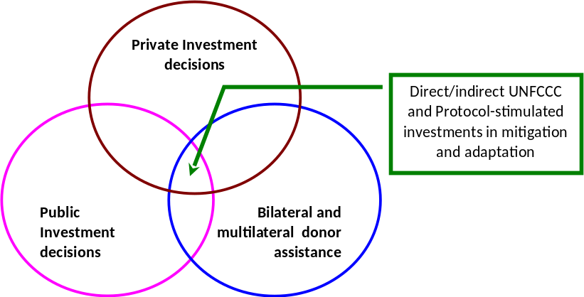

Exhibit 1: Power Plants Operator models
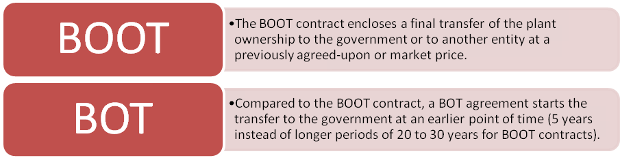

CSP TT NAM project is government led, development based and private sector driven. The above operator models are both institutionally feasible, i.e. Suntec Namibia (private sector) is anticipated to design, finance (debt/equity), construct, and operate the CSP plant for a certain concessionary period. Suntec Namibia would assume responsibility for the completeness of the design, any risk associated with construction, and the control of operational costs, all of which would be reimbursed by the collection of revenue from the off-takers. Suntec would be granted a specific concessionary period, after which time the contract might be renewed at the option of the government, or title would be transferred from Suntec to a government agency. The life span of the project is 20 – 25 years. Suntec also recognize the value of having respected local participants on the project.
At the current state only with the political willingness CSP TT NAM project can be developed. If political decision makers (MME & ECB) foresee their own benefits (like chances for employment or a possible solution for domestic energy problems) a financial/political support from GRN should be provided. This is on the backdrop that CSP projects do not (yet) pay for themselves, the project financing is often the most difficult part of the project development. Feed-in tariffs ensure the payment. Based on the feed-in tariff levels and specifications private investors calculate the profitability of a potential plant. This support mechanism improves the process of making the project bankable because of the long-term guarantees and continuous revenue flows to the owners and consequently to the creditors. However, if the tariffs are set too liberal the country cannot control the number of plants constructed, as it has happened in Spain in the PV market. In North Africa so called PPA (power purchase agreements) assure the financing very often. A PPA works similarly to a feed-in-tariff but the state controls the number of plants as every plant is tendered separately. This leads to individual and always slightly different conditions for every built plant, but also it prohibits a dynamic market evolution and replicability.

Labour Impact: Job Creation

CSP TT NAM project will add valuable economic benefits to the economy of Namibia through the creation of new jobs, GDP growth, and energy security. These prospective economic benefits are to be taken into account in setting up the financial support plan, since they are key in the establishing long-term economic benefits for the country. Further, the technical know-how in renewable energy technologies would increase in Namibia.

In the following table, the results of the labor impact assessment give the numbers of direct job creation during CSP plant construction. The operation and maintenance of the plant will also create long-term employment in the solar sector as about 41 jobs are needed to run a reference (50MW) power plant. Because of the replacement of components and equipment, the plant maintenance also has an indirect impact on new jobs. Many new jobs in construction and O&M will also have an impact on induced jobs in the region were the plant will be located. Number of indirect jobs for construction and O&M will increase other induced jobs. This leads to higher wealth and income of the region when new services and products for their private consumption are demanded.

Table 8: Shares in the value chain as well as other important parameters for a typical CSP plant

Components | Cost share of 50  MW parabolic  trough plant with  storage (7h) | Typical  investment in new  factory | Annual  output of  typical  factory | Jobs created | Direct  Jobs per  year / MW | Share  of  labor | Synergies with  other industries /  potential sidemarkets
Civil Work | Infrastructure: 5.8 %  Solar field:  3.1 % | - | - | 250-350 oneyear  jobs per 50  MW | 5-7  Jobs/MW | High | High
Installations on the site | 5.3 % | - | - | 100 one-year  jobs per 50 MW | 2  Jobs/MW | High | High
EPC Engineers and Project  Managers | 7.7 % | - | - | 30 – 40 one-year  jobs per 50 MW | 0.6 – 0.8  Jobs/MW | High | High
Assembling | 2.5 % | - | - | 50-100 one-year  jobs per 50 MW | 1-2  Jobs/MW | High | High
Receiver | 7.1 % | 25 Mio  Euro | 200 MW | 140 jobs | 0.3 – 0.7  Jobs/MW | Low | Very low
Mirror  flat  (Float glass) | ~ 4 % | 26 Mio  Euro | 1 Mio mirrors  200-400 MW | 250 jobs | 0.6 – 1.2  Jobs/MW | Mediu  m | High
Mirror  parabolic | 6.4 % | 30 Mio  Euro | 1 Mio mirrors  200-400 MW | 300 jobs | 0.7 – 1.5  Jobs/MW | Mediu  m | Low (if glass  production is  included then high)
Mounting structure | 10.7 % | 10 Mio  Euro | 150-200 MW | 70 jobs | 0.3 – 0.5  Jobs/MW | Mediu  m | Medium
HTF | 2.1 % | Very large | Large | Not identified |  | Low | Low
Connection piping | 5.4 % |  |  |  |  | Low | Medium
Storage system | 10.4 % | - |  | 50 jobs |  | Low | Low
Electronic equipment | 2.5 % | Medium | Medium | Not identified |  | Mediu  m | Medium
Reference CSP Plant (50 MW,  7,5 h storage) | 100% | - | Current  plants  50 MW to  100 MW | 500 one-year  jobs per 50 MW  (only on the plant  site) | 10  Jobs/MW  only on  the plant  site | High | -

ANNEX 5: DETAILED CO2 CALCULATONS AND ASSUMPTIONS

- Direct Emission Reductions
Since commissioning of the first CSP plant is not expected until after the completion of the 3-year CSP TT NAM project, no direct emission reductions are expected on this project.

- Direct post-project emission reductions

Since the project does include activities that would directly result in GHG emission reductions after the completion of the Project, direct post-project GHG reductions are expected. They have been calculated as follows:

  - Base case - With no estimates of MWh generated from proposed 50 MW CSP plants, assumptions on MWh generated were made using an average net capacity factor of 40% based on July 2012 Pre-feasibility CSP Overview by MME (on pg 5) that assumes CSP plant has thermal storage to meet peak demand in the evening;
  - First CSP plant commissioned in 2016;
  - Two other 50 MW CSP plants were assumed to be commissioned in 2017 and 2018;
  - Average number of hours that CSP plant is 24 hrs, 365 days per year;
  - Grid emission factor is 1.0136 t CO_{2eq} /MWh that assumes carbon reductions are resulting from the offsetting of power imported from South African thermal power stations;
  - One 50 MW plant will generate 175,200 MWh annually (50 MW x 24 hrs x 365 days x 0.40);
  - With the 1.0136 t CO_{2eq} /MWh grid emission factor, emission reductions are 177,583 t CO_{2eq} annually from each 50 MW CSP plant.

According to the June 2012 IRENA CSP report (http://www.irena.org/DocumentDownloads/Publications/RE_Technologies_Cost_Analysis-CSP.pdf), the ranges of CSP capacity factors with storage for parabolic troughs and solar towers are 40-53% and 40-45% respectively for 6-hour storage. While a final technology option has not been selected for this pilot CSP project, the MME’s CSP Pre-Feasibility Study of July 2012 leans heavily towards parabolic troughs and power towers and molten salts for cooling given that these are the most commercially advanced CSP technologies available. As such this is the most likely scenario and is labelled the “base case.” If the parabolic trough technology with no storage is implemented, the capacity factor is projected to be in the range of 20-25%.

As such the ER calculation range for the two scenarios (base case and low end) are as follows:

- Direct post-project GHG reductions for this project will range from 177,583 tCO2/yr (for each 50 MW CSP plant with storage) to 88,791 tCO2 (for each 50 MW CSP plant without storage);
- The 10-year cumulative GHG emission reductions from three CSP projects implemented over the next 3 years after the end of the Project will range from 4.79 million tons CO2eq (with storage) to 2.40 million tons CO2eq (without storage).

The summary of estimated emission reductions for the base case and low end case over the 10-year GEF influence period is provided on Table 8.

- Indirect emission reductions (bottom-up)

Indirect emission reductions were calculated by assuming a “top-down” 60% causality factor (“substantial but modest”). The P10 based on 3 CSP plants (base case assumptions) constructed after the end of CSP TT NAM is 4.795 million tonnes CO_{2eq}. After applying the 60% causality factor, indirect emission reductions from this project were calculated to be 2.877 million tonnes CO_{2eq.}

Table 8: Calculation of Direct Post-Project Emission Reductions from CSP Plants (base case and low end case)

Base Case Scenario – Table A

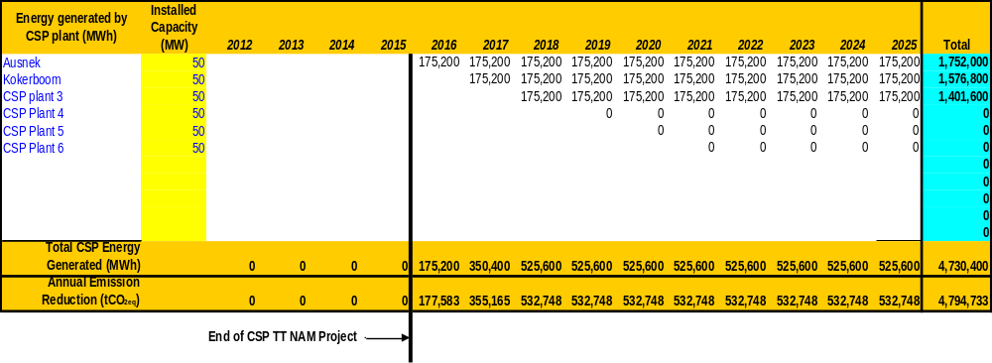
Low End Case Scenario – Table B

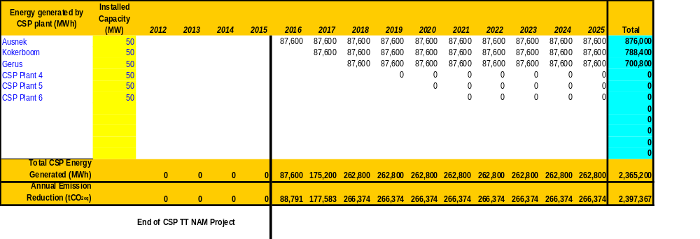

www.oanda.com (exchange rate effective August 13, 2012)
The Republic of Namibia: www.grnnet.gov.na.
Population Reference Bureau: http://www.prb.org/ (data for 2008).
White Paper on Energy Policy of 1998 is clear on the need for diversification in the national energy mix
Ministry of Mines and Energy, “Pre-feasibility Study for the Establishment of a Pre-Commercial Concentrated Solar Power Plant in Namibia”, July 2012, and the “Capacity Building Roadmap and Technology Transfer Programme”, July 2012
IPCC, 2000
Ibid 5. Technologies included parabolic trough, central receiving (tower technology), lineal Fresnel reflectors, and Stirling engines with parabolic dishes.
http://www.solarpaces.org/Library/Legislation/docs/040327RD436-2004.pdf
http://www.desertec.org/en/foundation/
www.csp-world.com
Price Henry & Carpenter Stephen. 1999. The Potential for Low-Cost Concentrating Solar Power Systems. NREL, Colorado
The TREE project promotes capacity building and know-how transfer for both decision makers from politics and business, as well as technicians and engineers: http://www.tree-project.de/course-program/course-details/course/16
ECB`s Development of a Procurement Mechanism for RE Resources in Namibia, November 2010
Ibid 5
Ibid 5
Ibid 5
Grama 2008
Merrill Lynch
CSP Today, 2008
Electric Power Research Institute, EPRI, 2007
Bank of Namibia, 2005
Ibid 5
Ibid 5
Ibid 5
NamPower Annual Report, 2010
Ibid 5
Ibid 5, Figure 3.2
REEEI 2010
Ibid 5
www.met.gov.na
Energy White Paper of 1998
Ibid 6
Ibid 6
MME, July 2012. “CSP Pre-Feasibility Study, Capacity Building Roadmap and Technology Transfer Program”
Ibid 5
One of the biggest challenges of concentrating solar power (CSP) is the intermittency associated with clouds during the day, which can lead to transients and no steam generation, resulting in an undesired shut down of the turbine. This can be economically mitigated by a hybrid or back-up system with a readily available fuel such as biomass or coal. The hybridization, however, needs to be an integral part of the design, and thus the decision for hybridization needs to be made early in the design process.
This will involve the assessment, design and implementation of measures intended to reduce the perceived risks for private and public investors in CSP projects. This may include sovereign guarantees, defining clear liability responsibilities in case of default, and security of property rights and concessions, amongst other potential measures.
These streamlined procedures would include calls for tender (with standardized documentation for tender documents, CSP contracting, standardized PPP agreements and IPP contracts) and a comprehensive outreach campaign that targets potential developers, investors, suppliers and local stakeholders.
“Pre-Feasibility Study for a Pre-Commercial CSP Power Plant” funded by MME and EEP, July 2012
These plans would include amongst other designs the routing of the site access road to the site; provision of appropriate foundation designs of the various structures according to site geological conditions; review of the site design of against floods, wind storms and seismic events; precise layout of the solar field; thermal storage system design; and detailed design of the balance of plant (i.e. power plant, cooling system, substation).
This would include preparing applications for the environmental clearance of the project, and application for the license to construct the CSP.
This assumes a Namibian grid emissions factor of 1.0136 tonnes CO2eq/MWh from a UNEP Riso Center Study on “Analysis of the Grid Emissions Factor for the Electricity Sector, the Case of the Southern Africa Power Pool”.
Objective (Atlas output) monitored quarterly ERBM and annually in APR/PIR
Over a period of 10 years from 3 CSPs constructed during the 10-year period after the EOP, and with an assumed grid emissions factor of 1.0136 tonnes CO_{2eq}/MWh.
All outcomes monitored annually in the APR/PIR.
Three North-South and two South-South
Local firms could be involved with assembly and installation of solar fields, storage facilities, heat transfer equipment, boilers, steam turbines and condensers.
Investment grade solar resource data is solar satellite data correlated with ground measurements for a period of one year
Satellite irradiation data only available
These data are at priority sites for CSP development in Namibia as defined in the July 2012 Pre-Feasibility Study of CSP as funded by MME
Reference is made to World Bank procedures which are international norm for EIA
The amount is subject to further verification after additional CTF preparation funds become available and its rules finalized.
The BOOT was arrived at as alternative route to raise capital funding (venture capital through an IPP) under the intense competitive structure of the GEF PIF and as a service characteristic of technology item and technology commercialization strategies and management plans in view of technology transfer intermediaries.
User’s Guidebook for the Assessment of Investment & Financial Flows to address Climate Change - UNDP
Only in the case an investment decision is made
UNEP Riso Center, GFE Envest GmbH, African Carbon Asset Development (ACAD) Facility, “Analysis of Grid Emission Factors for the Electricity Section in Sub-Saharan Africa, The Case of the Southern African Power Pool”

